**Lab 8: BJT Amplifier Configuration**

**Faizan Bangash**

**Ecen 325-504**

**Date: 31st October, 2018**

**Calculations**

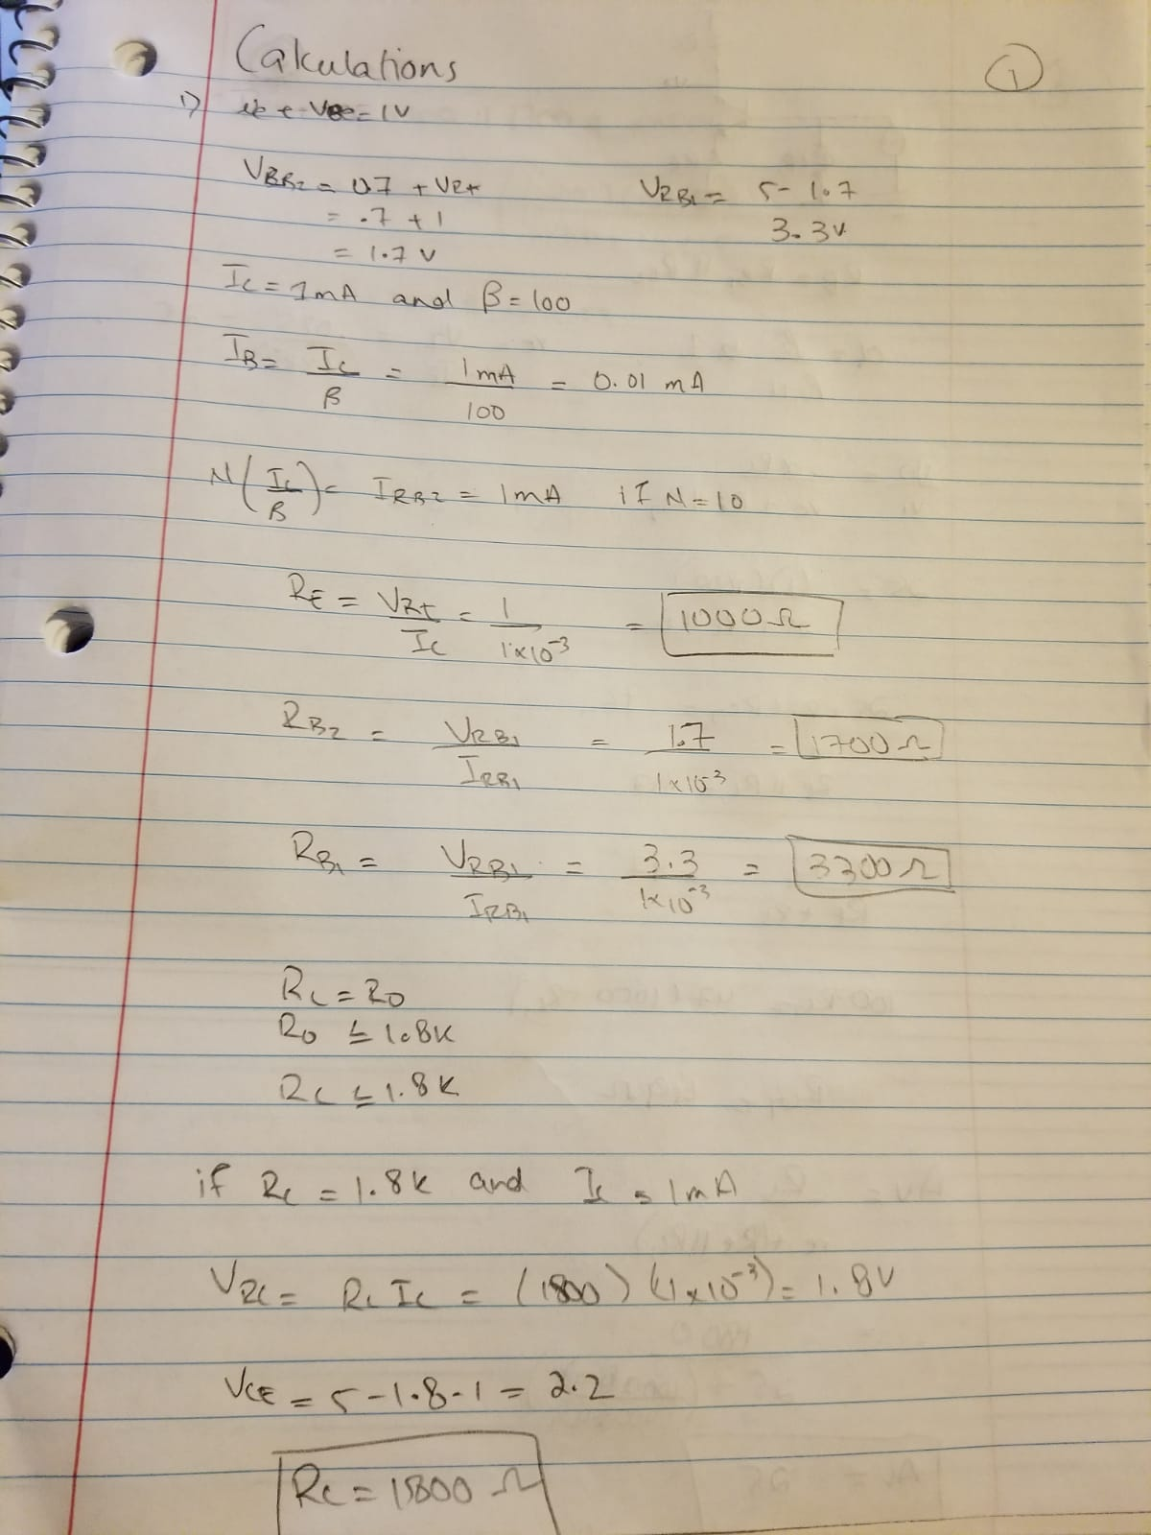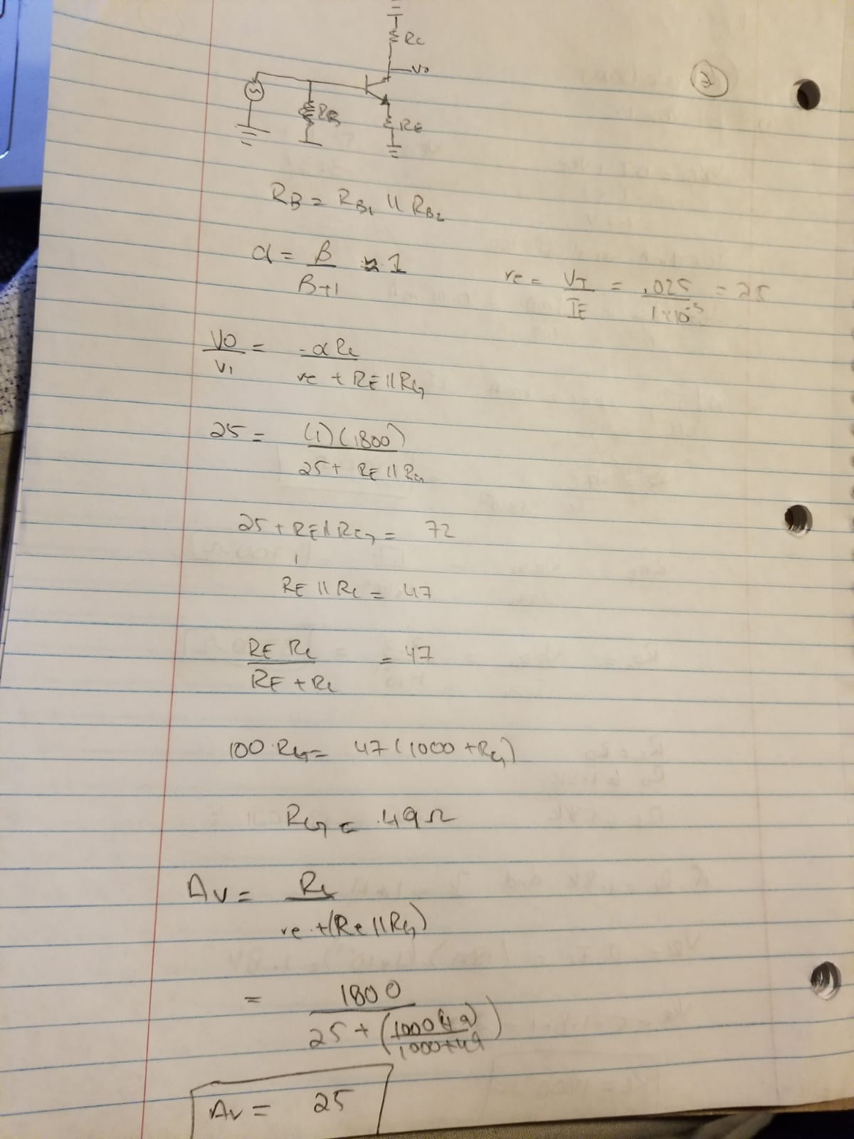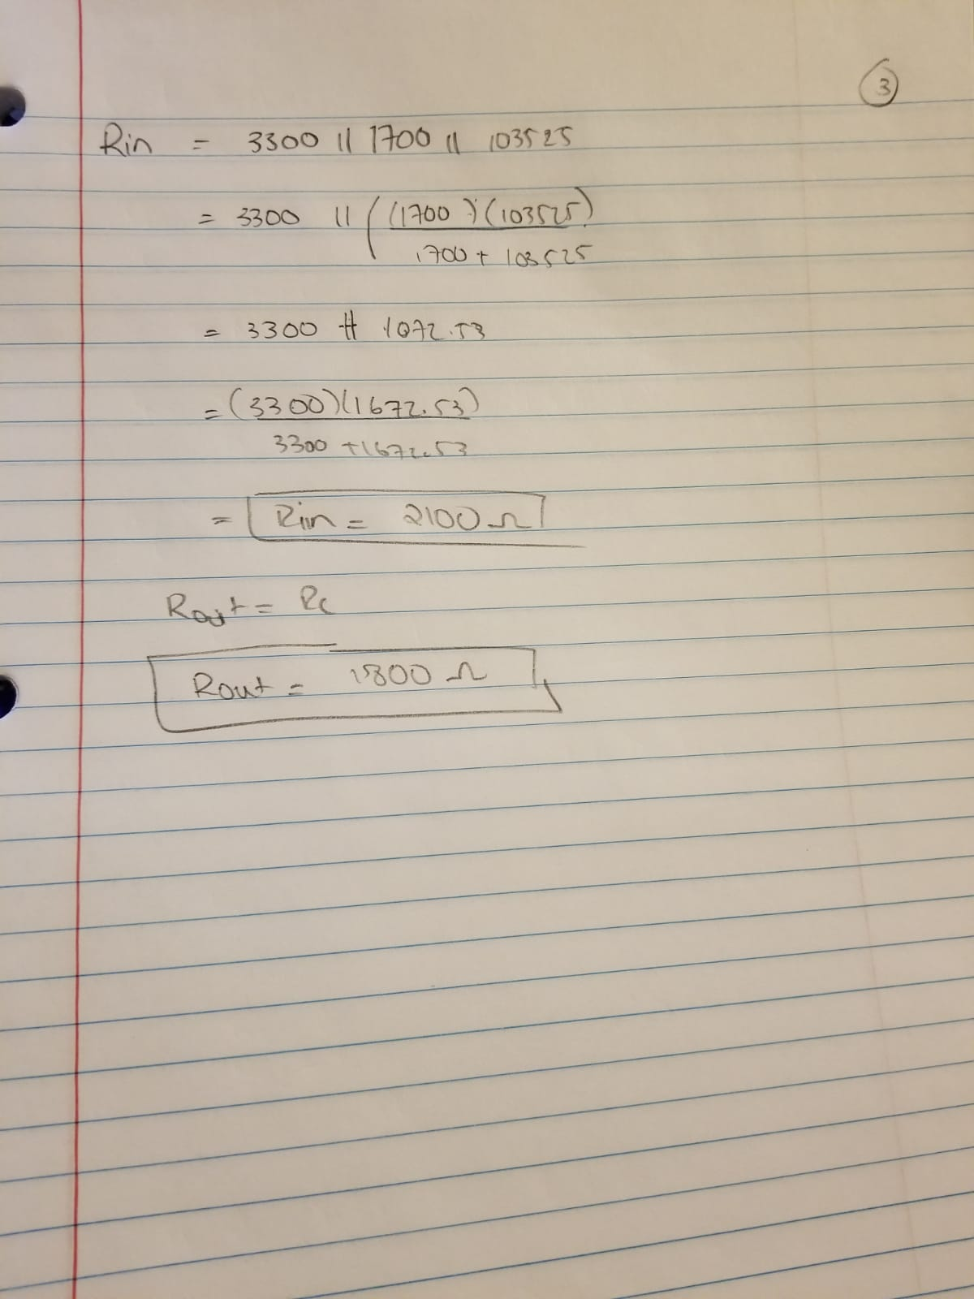

**Simulations**

NPN common emitter

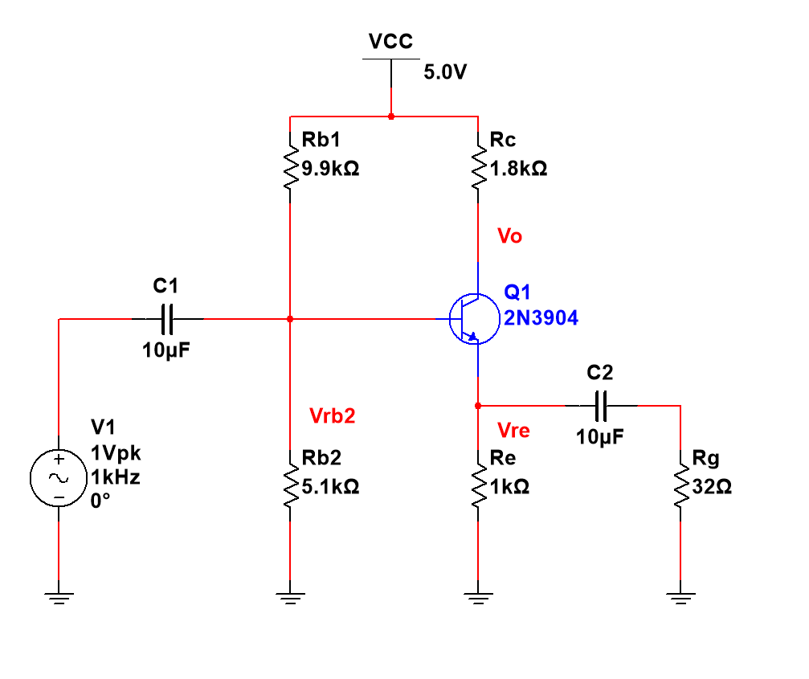

DC operating point

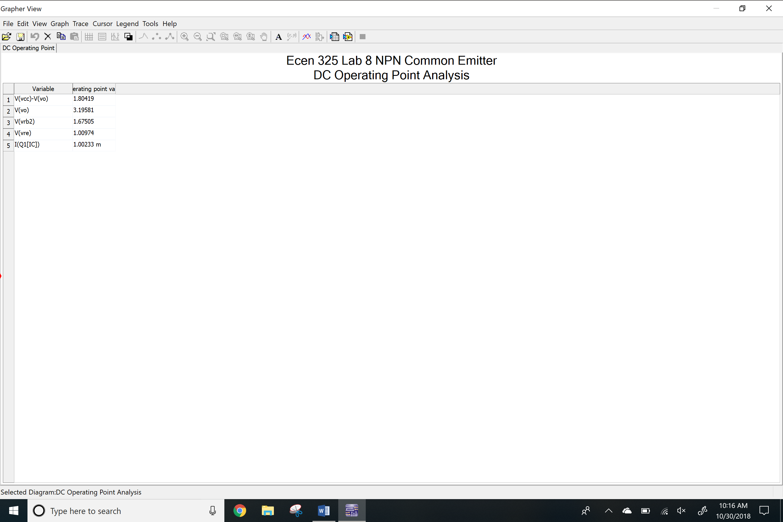

AC simulation Av

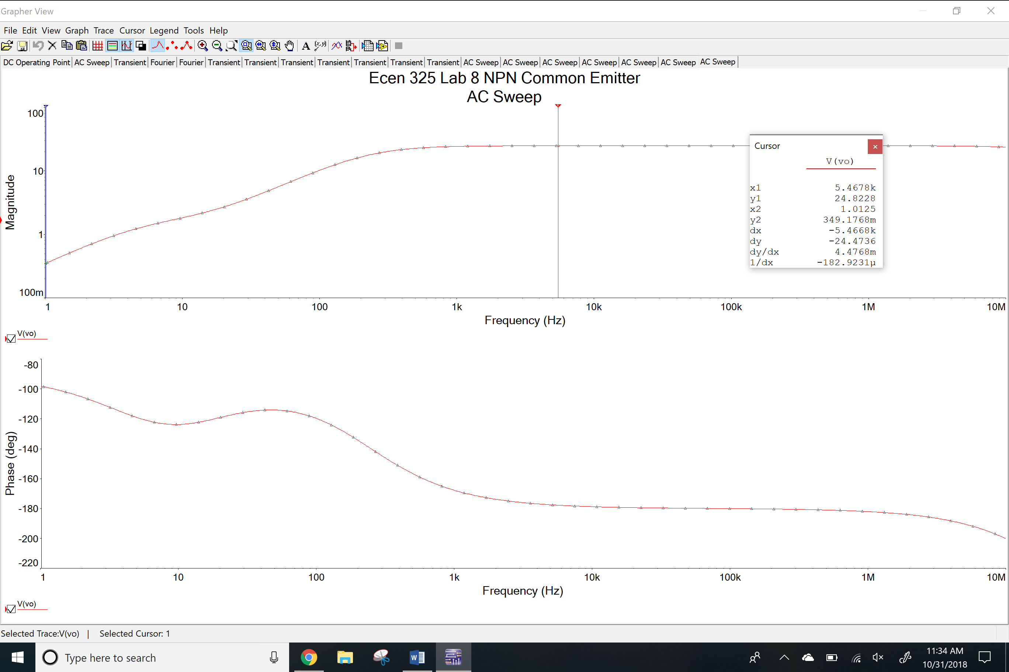

AC simulation Ri

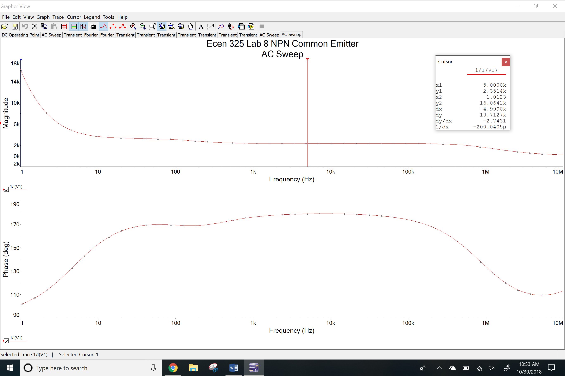

AC simulation Ro

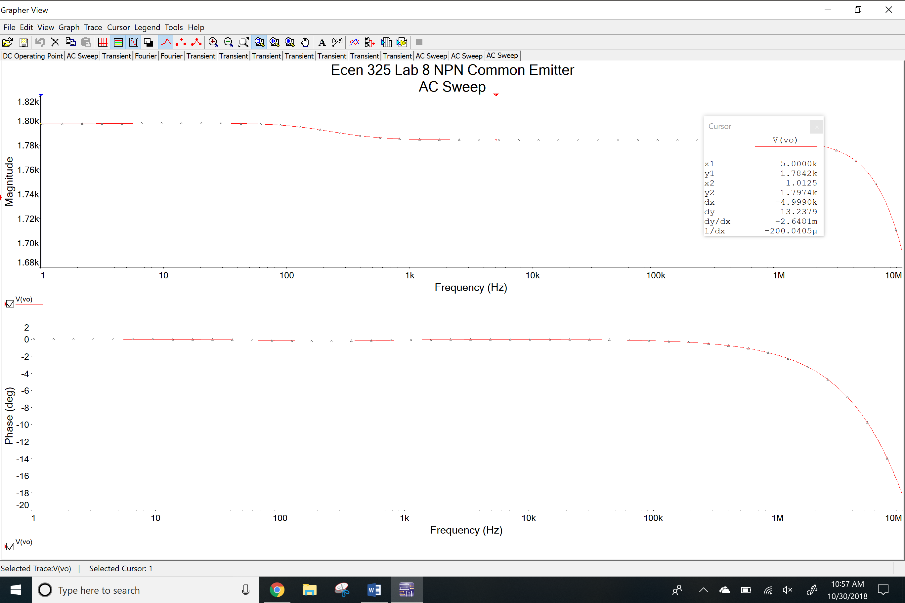

Transient simulation

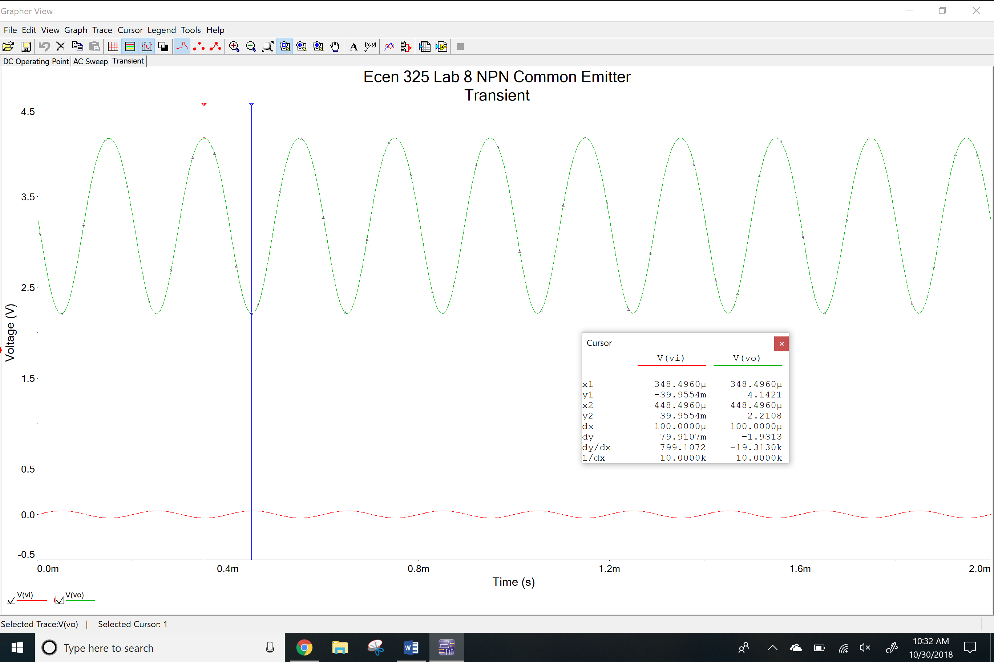

Total harmonic distortion

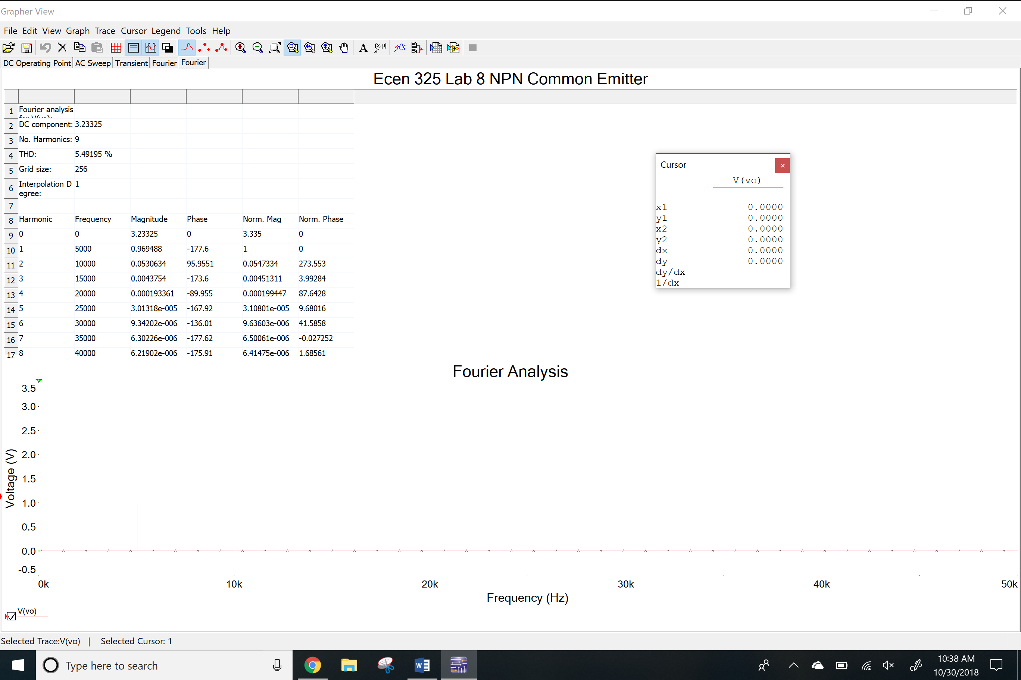

Clipping

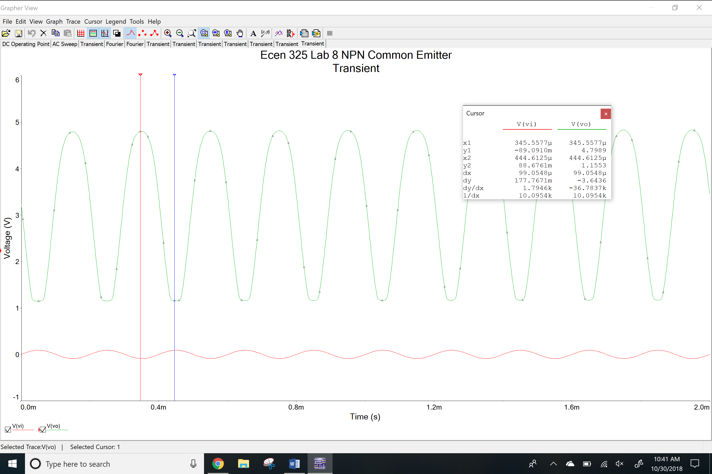

PNP common emitter

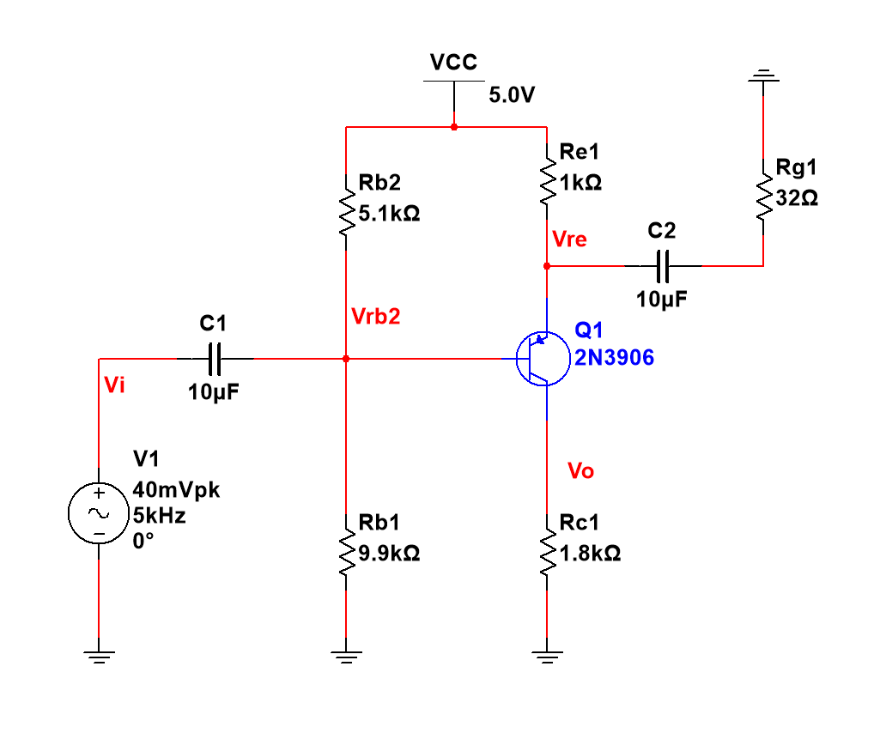

DC operating point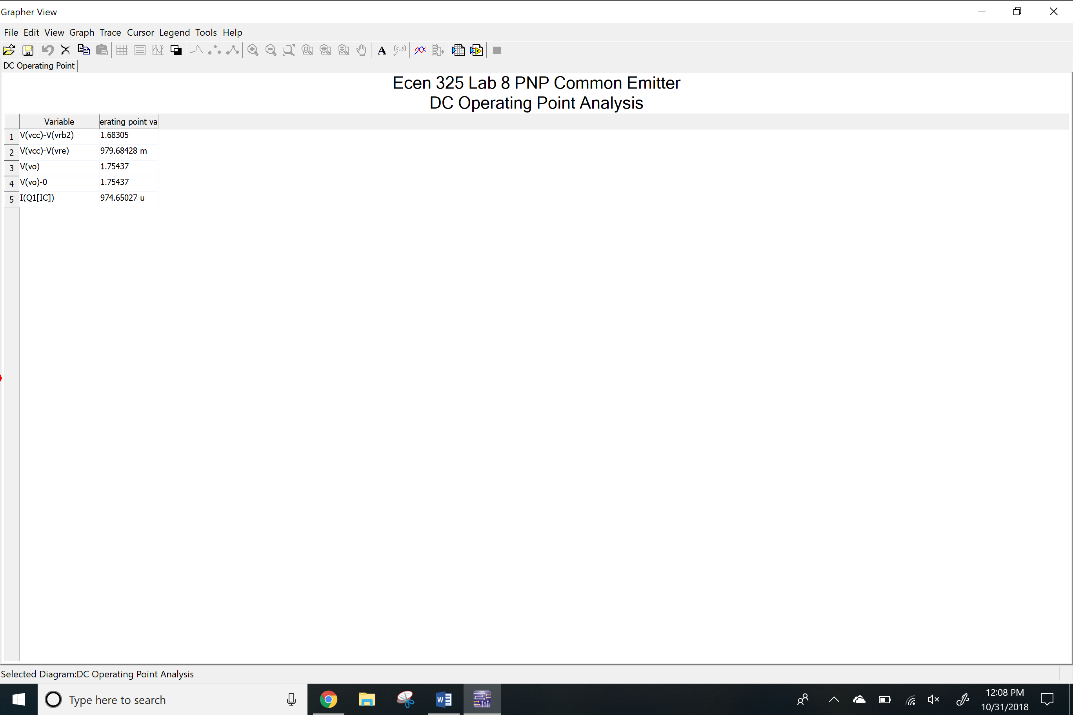

AC Simulation Av

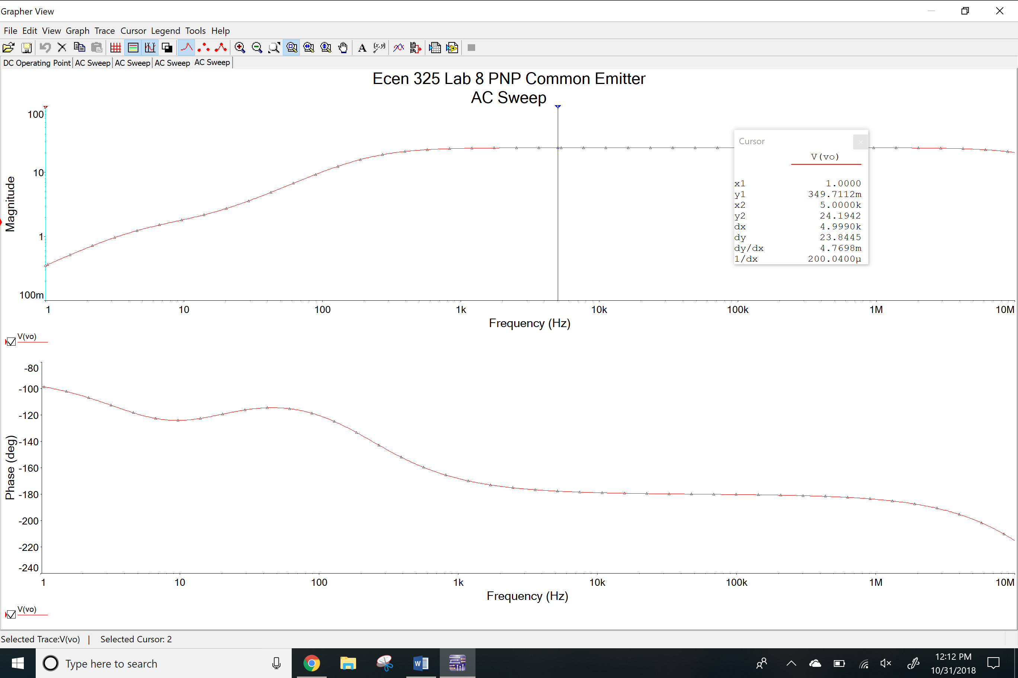

AC simulation Ri

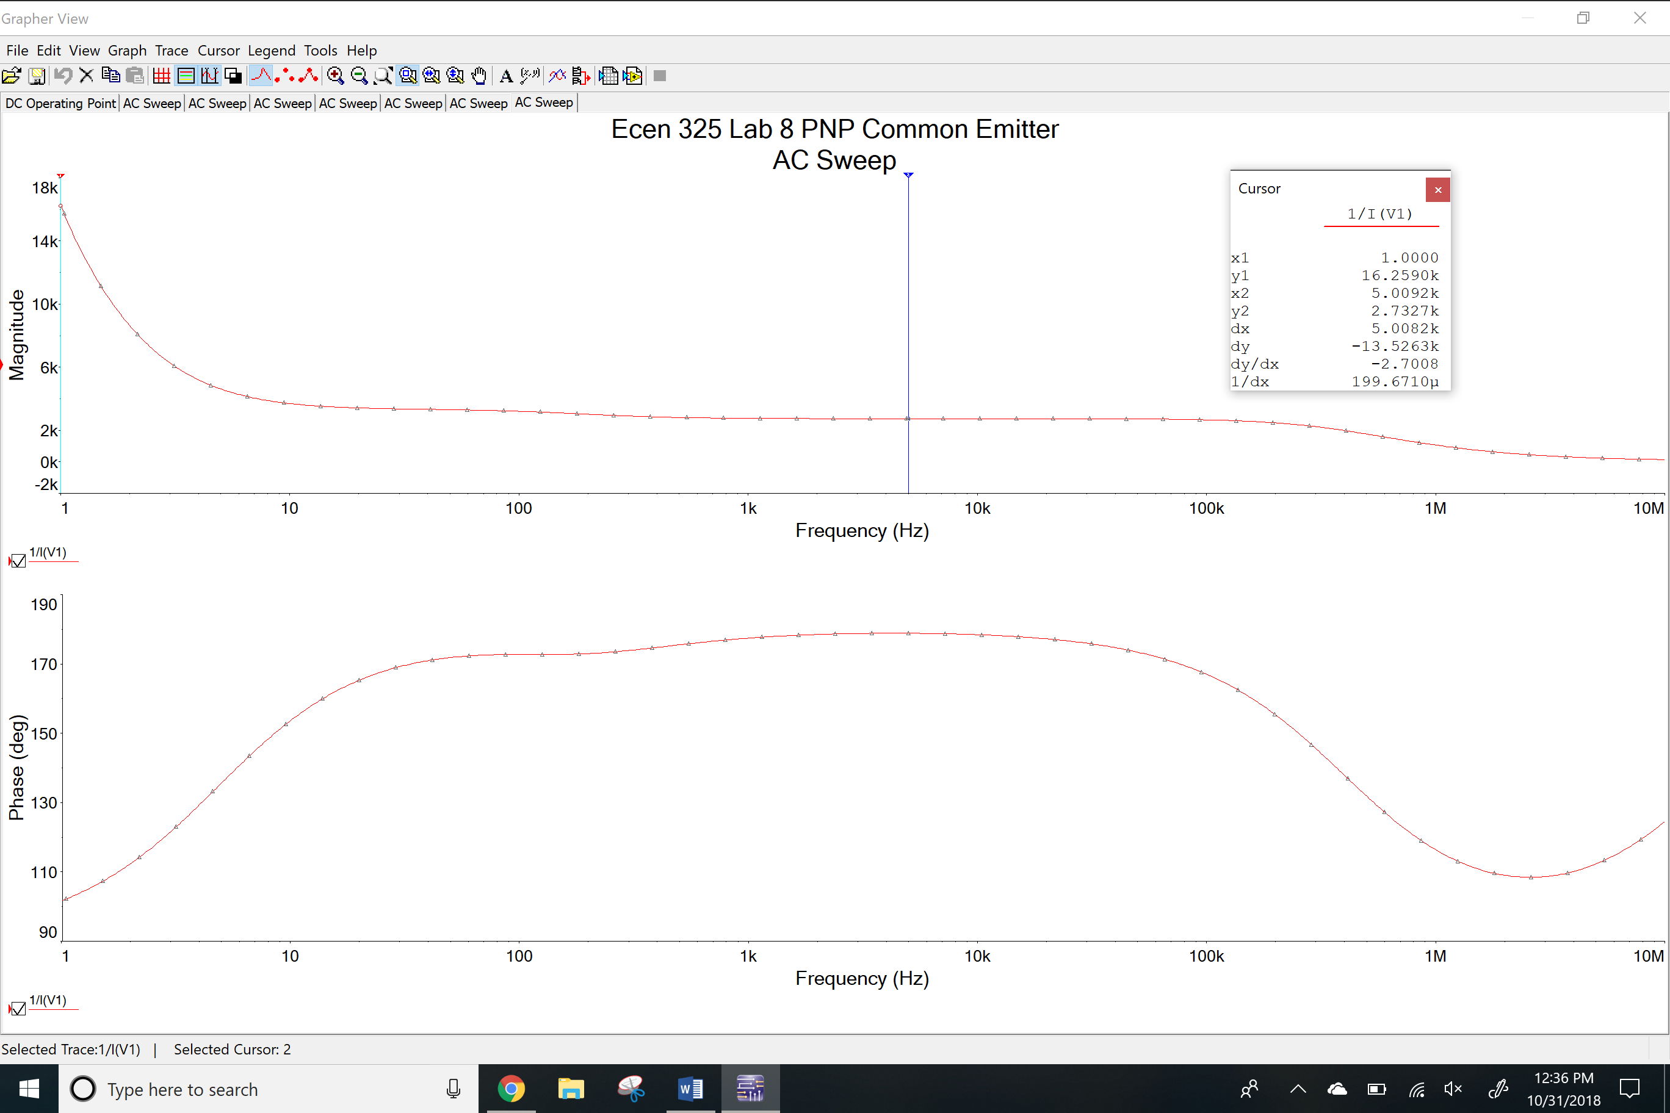

AC simulation Ro

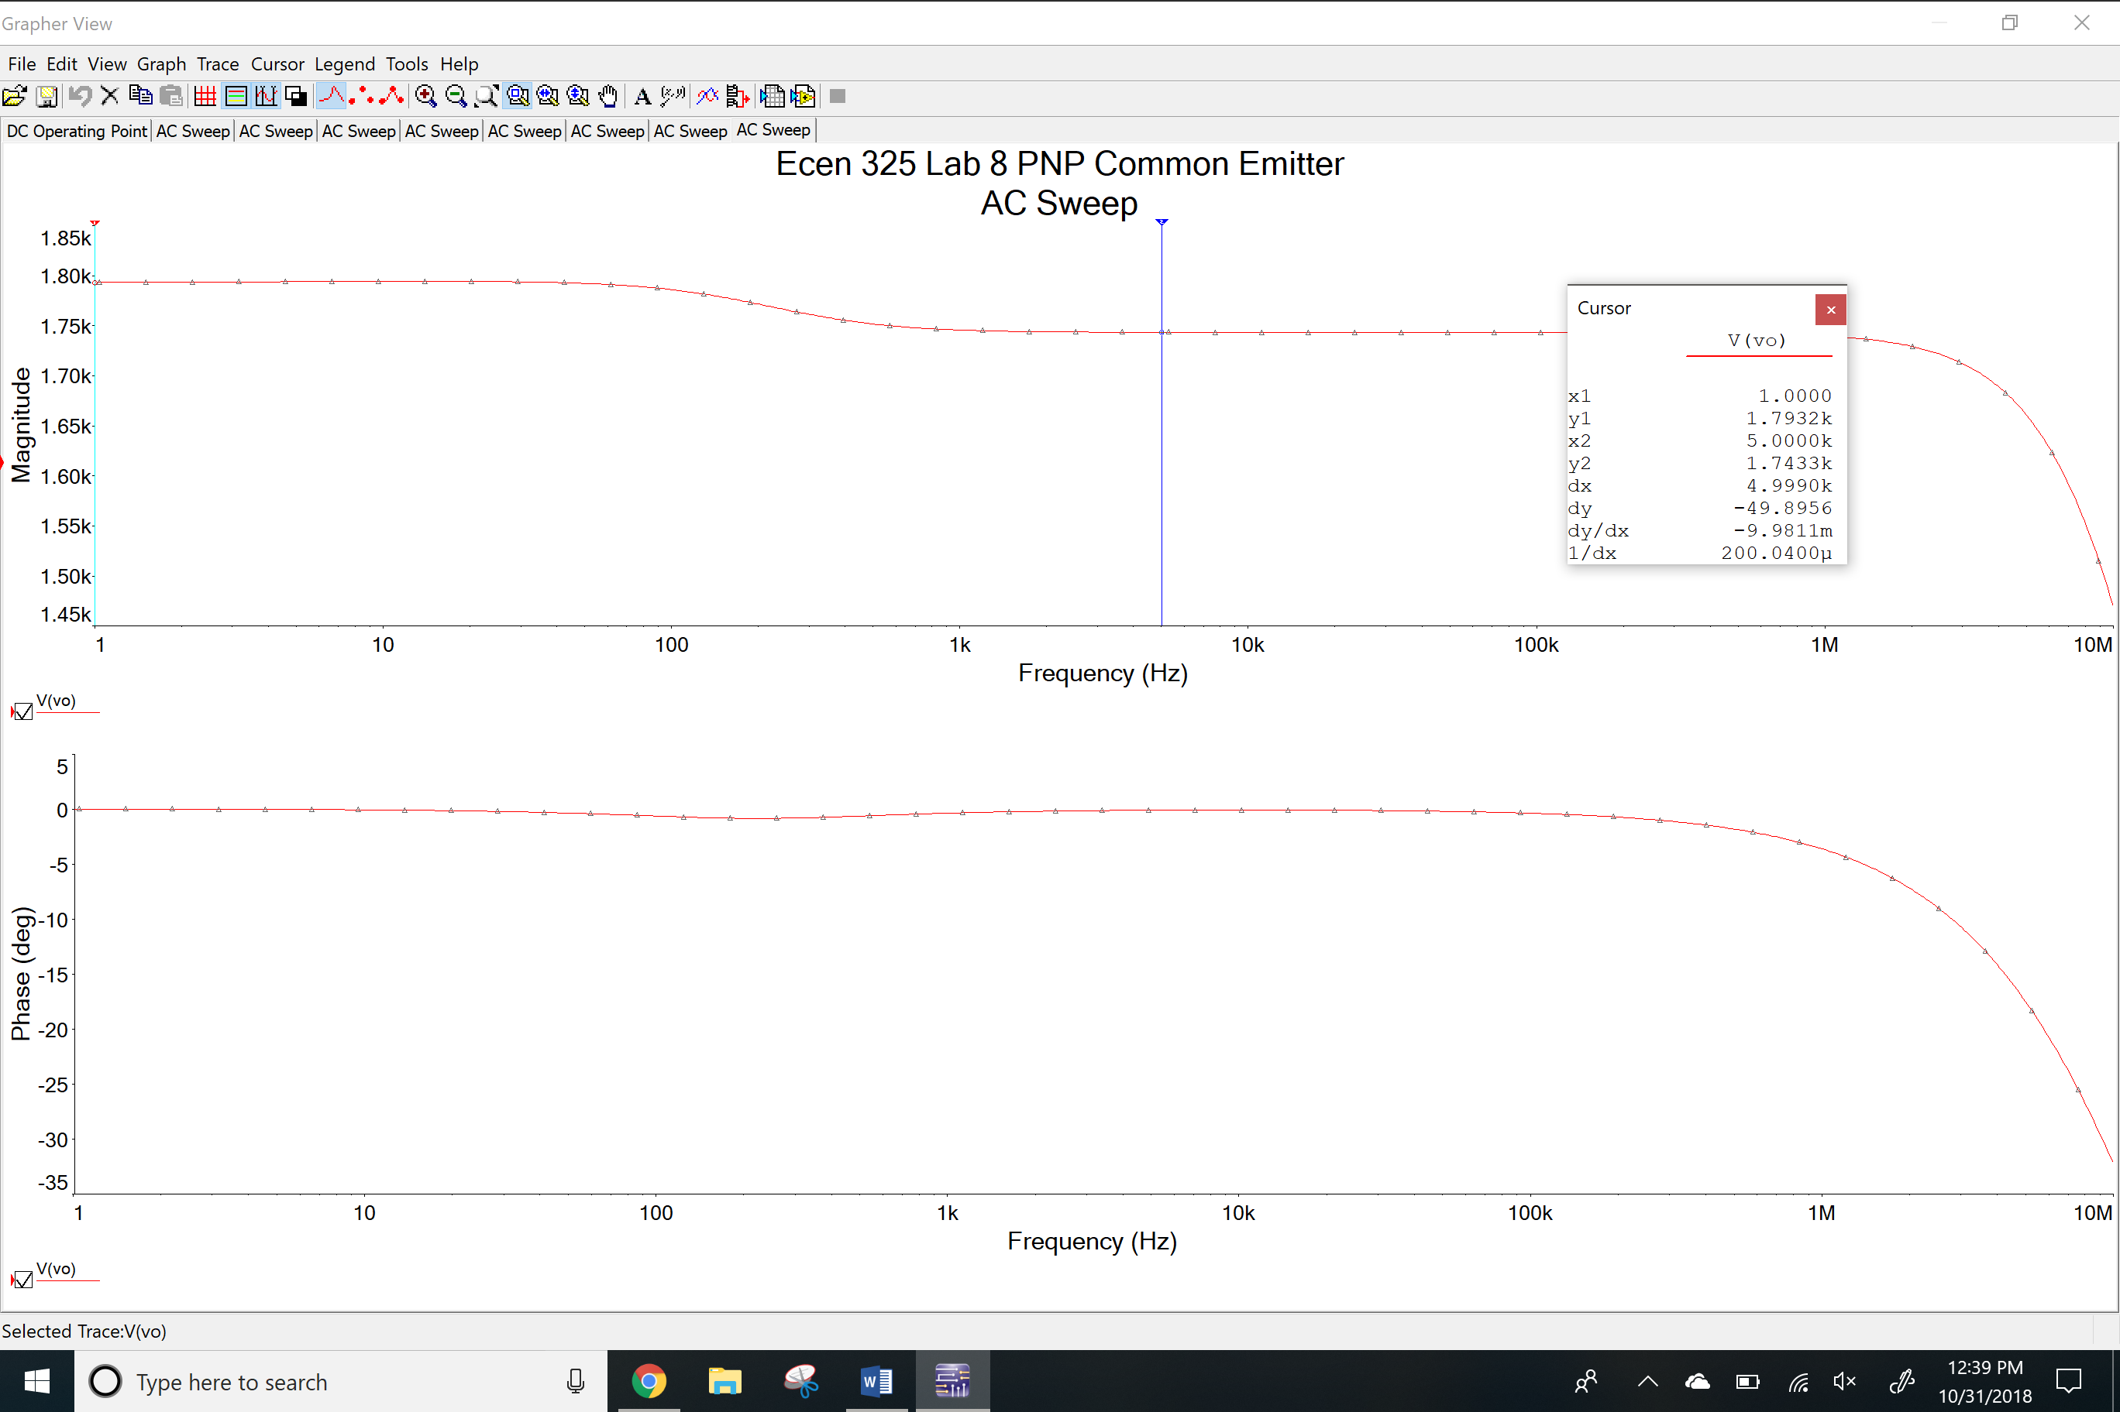

Transient simulation

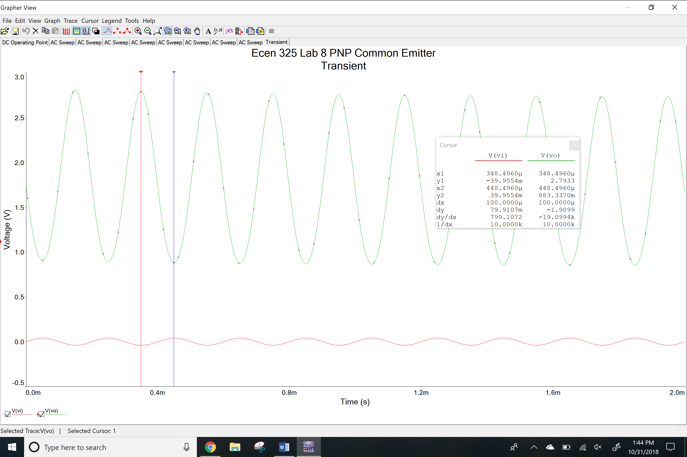

Total harmonic distortion

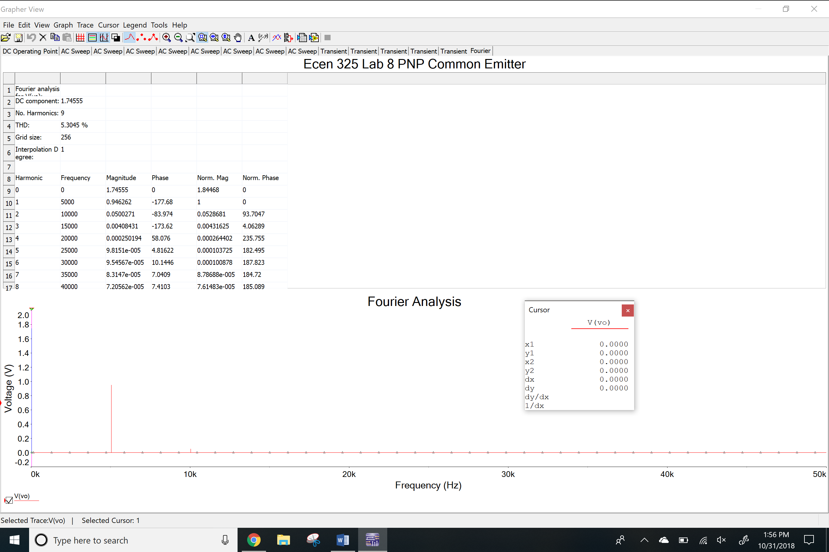

Clipping

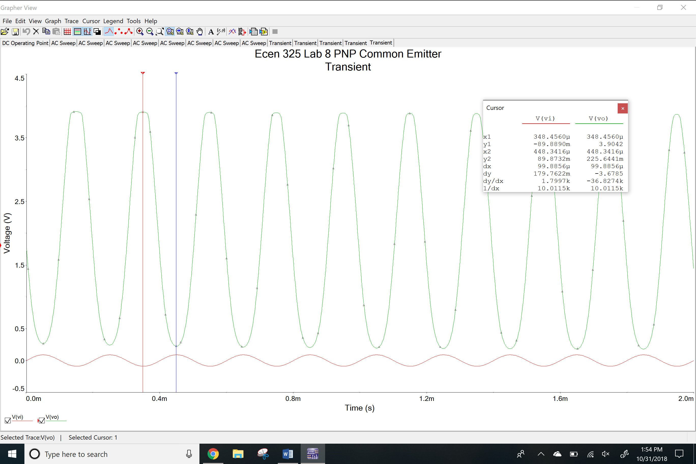

**Measurements**

NPN common emitter

Vo and Vrc

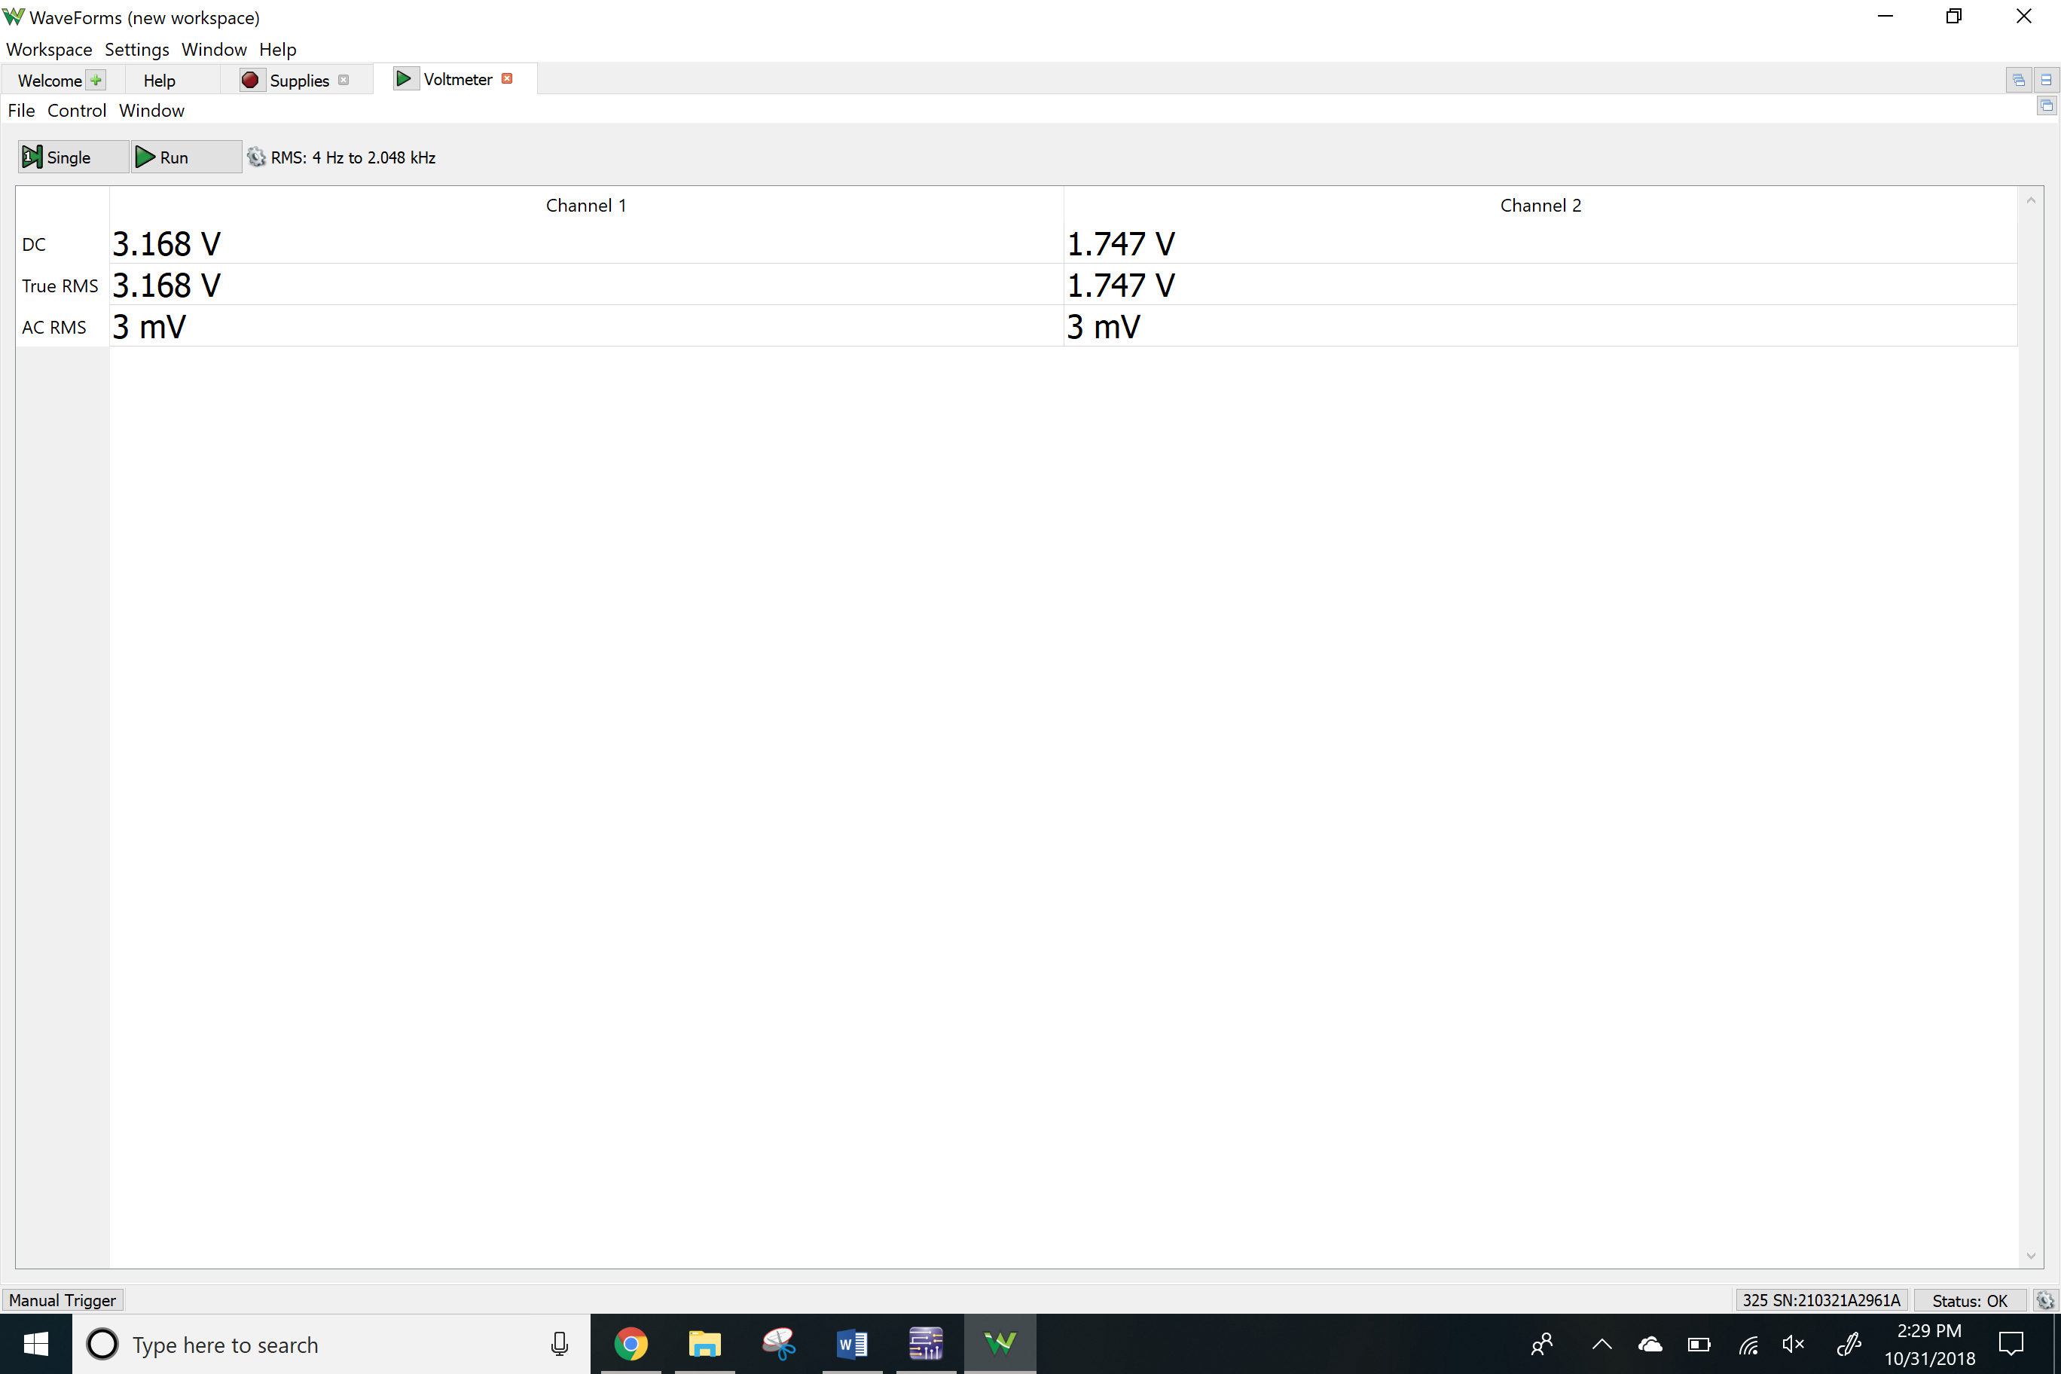

Vre and Vrb2

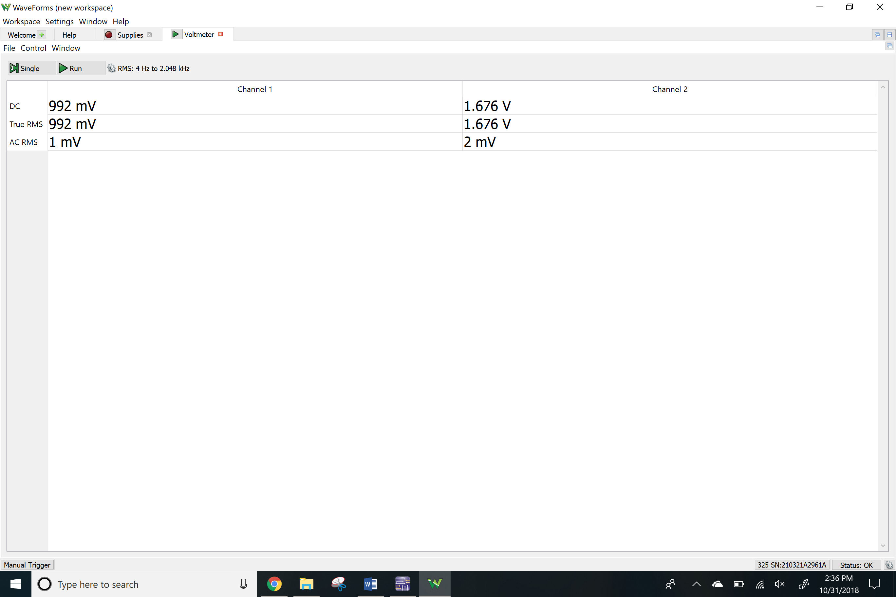

Network analyzer

Av

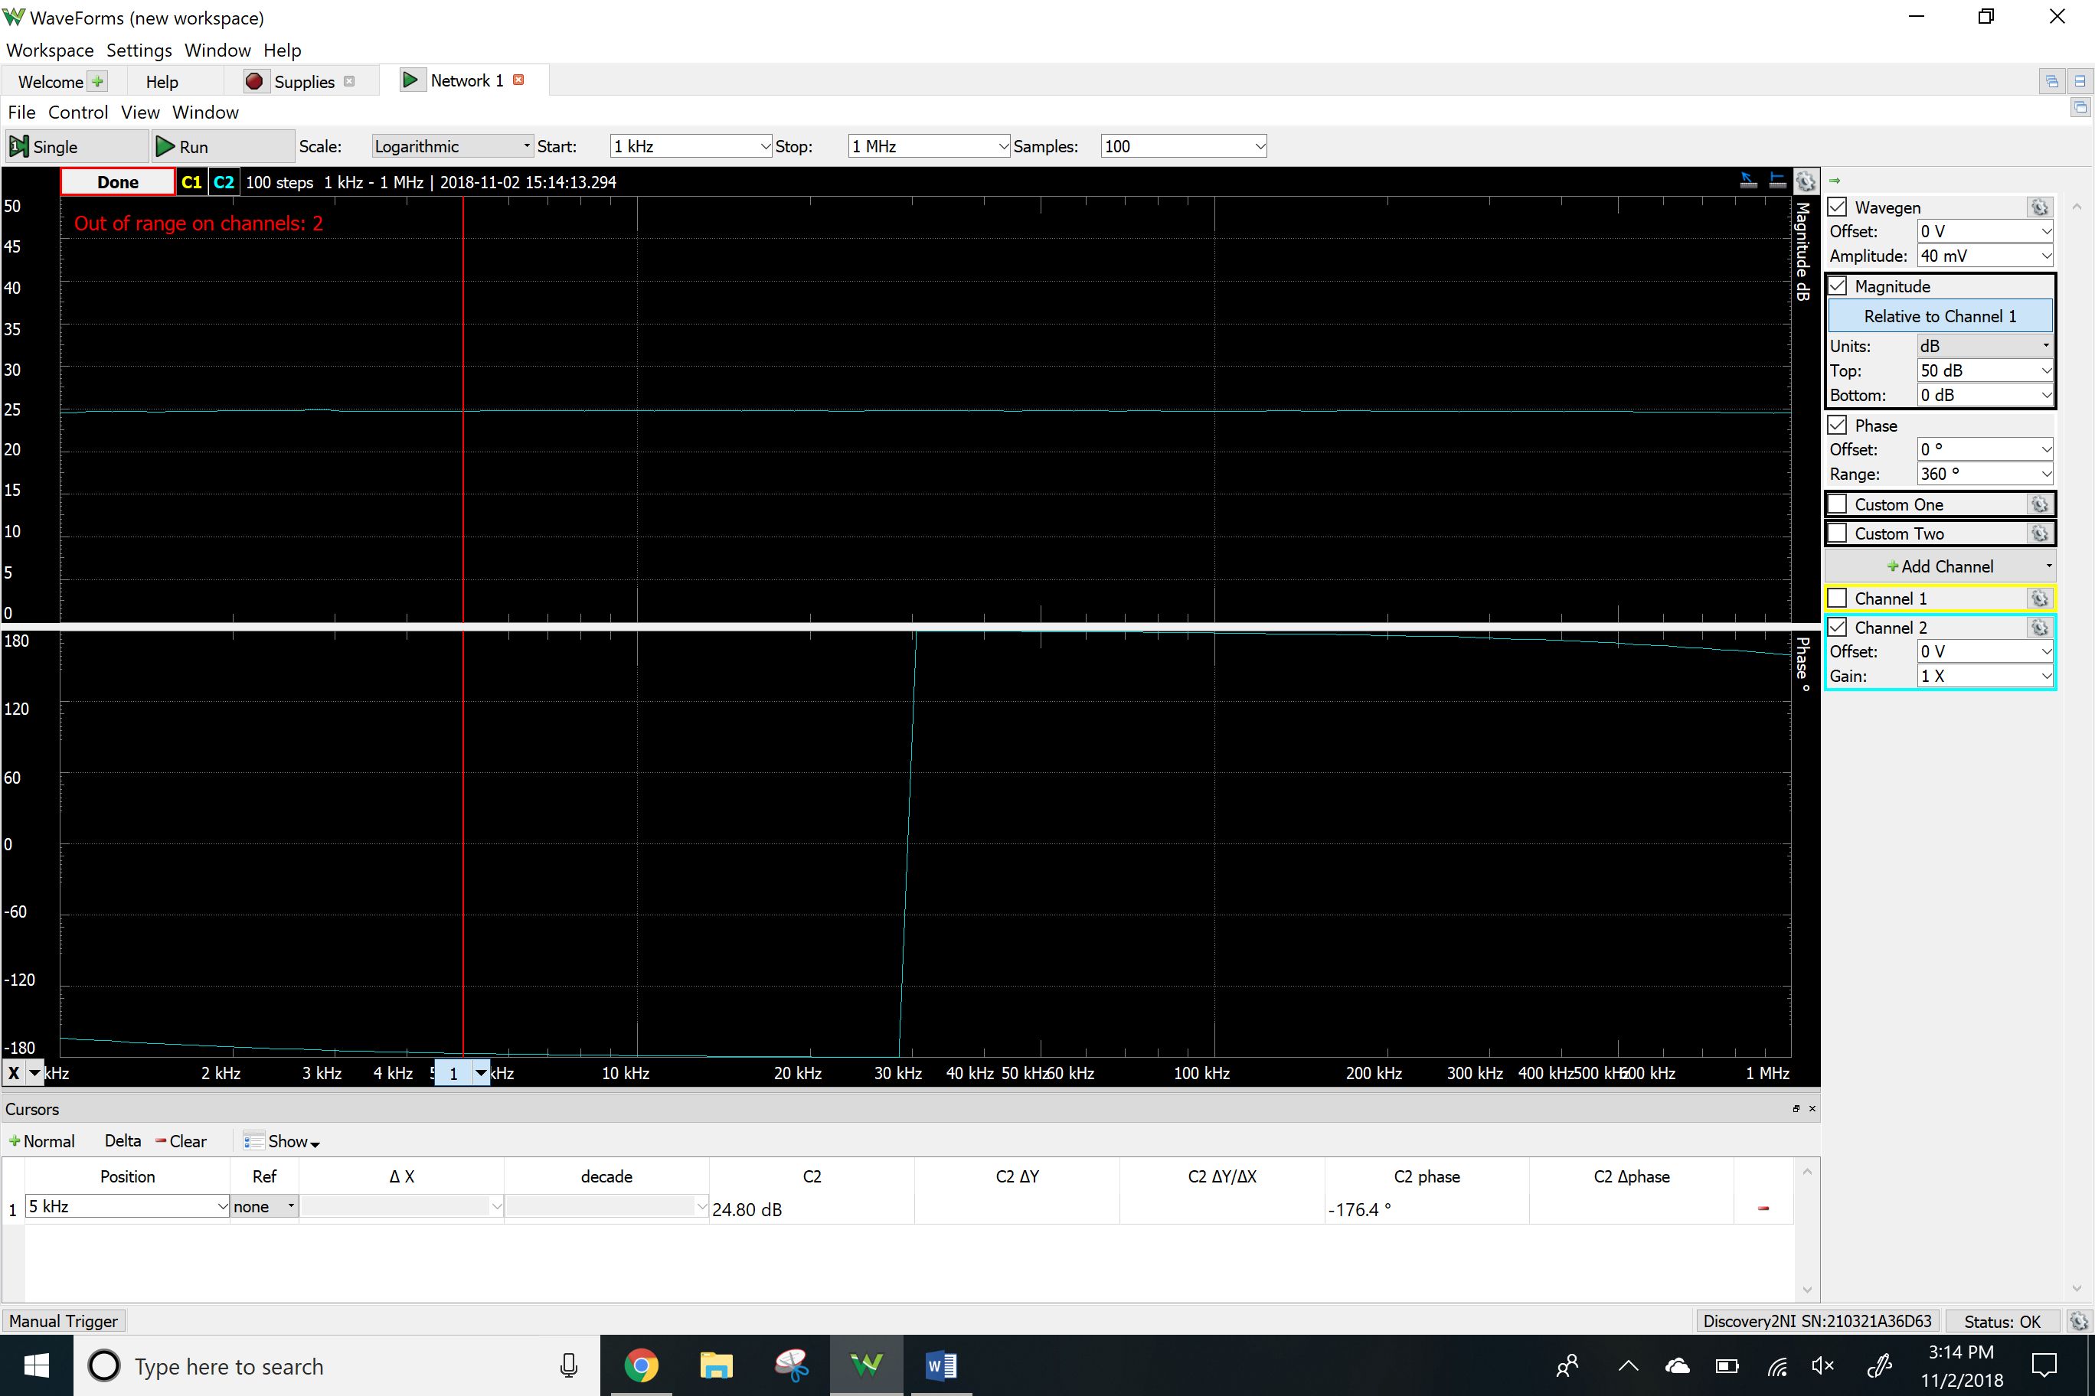

Ri

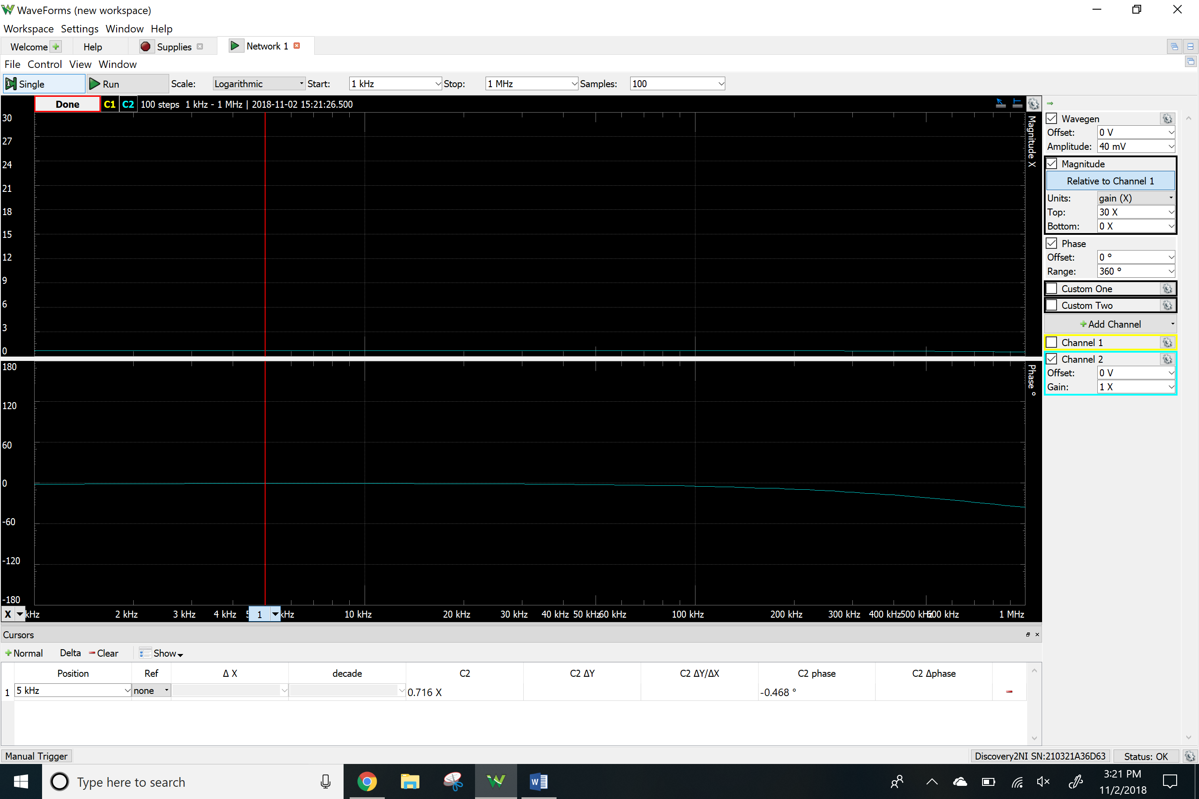Ro

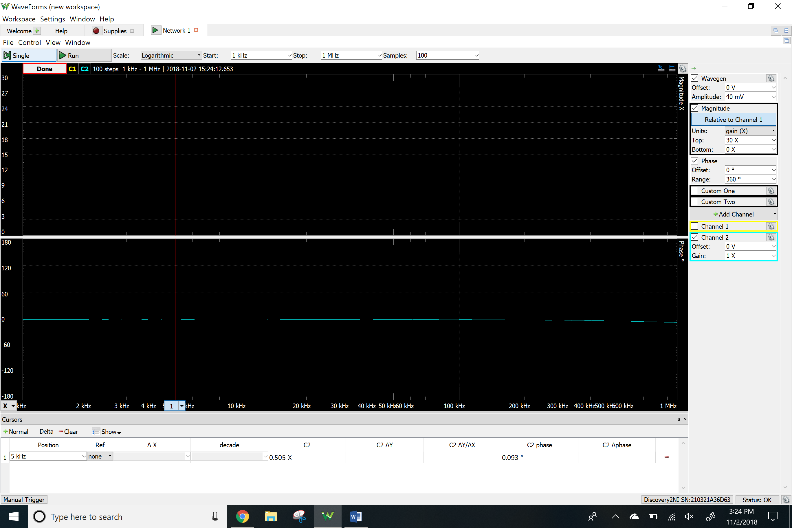

Time-domain waveform

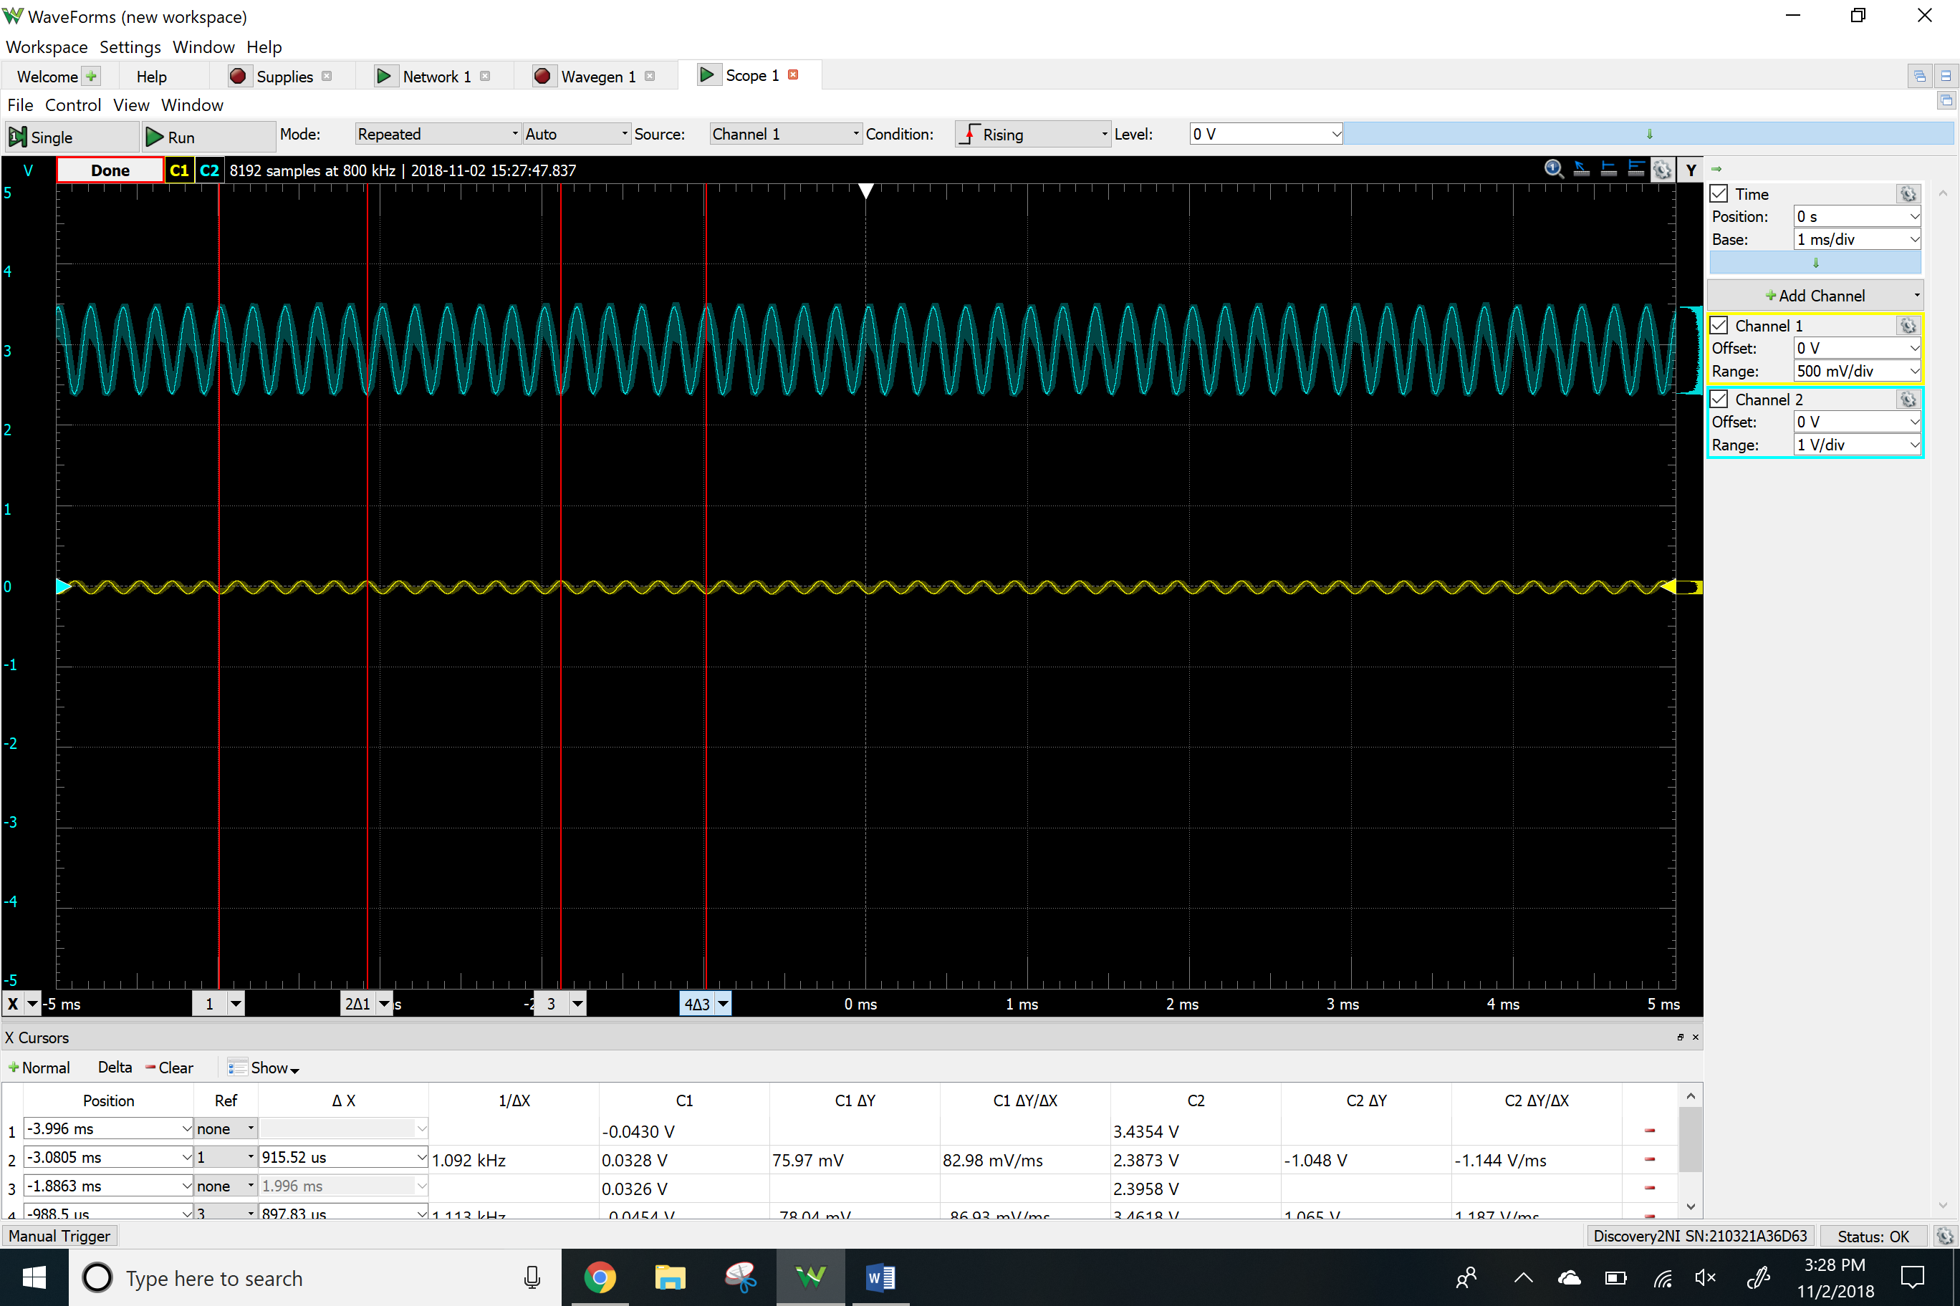THD

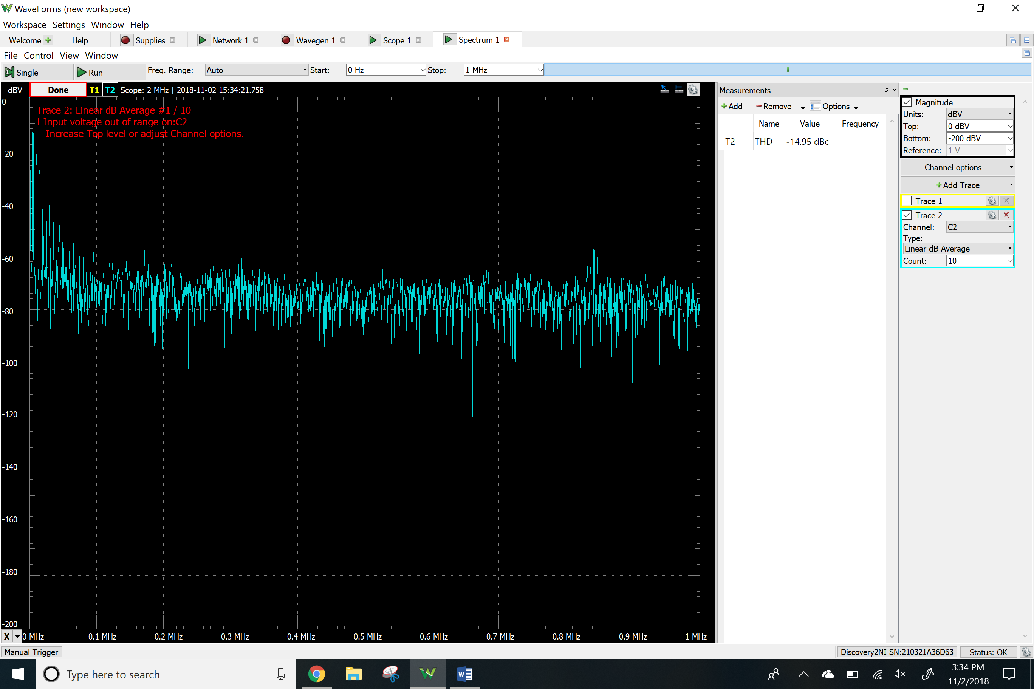

Clipping

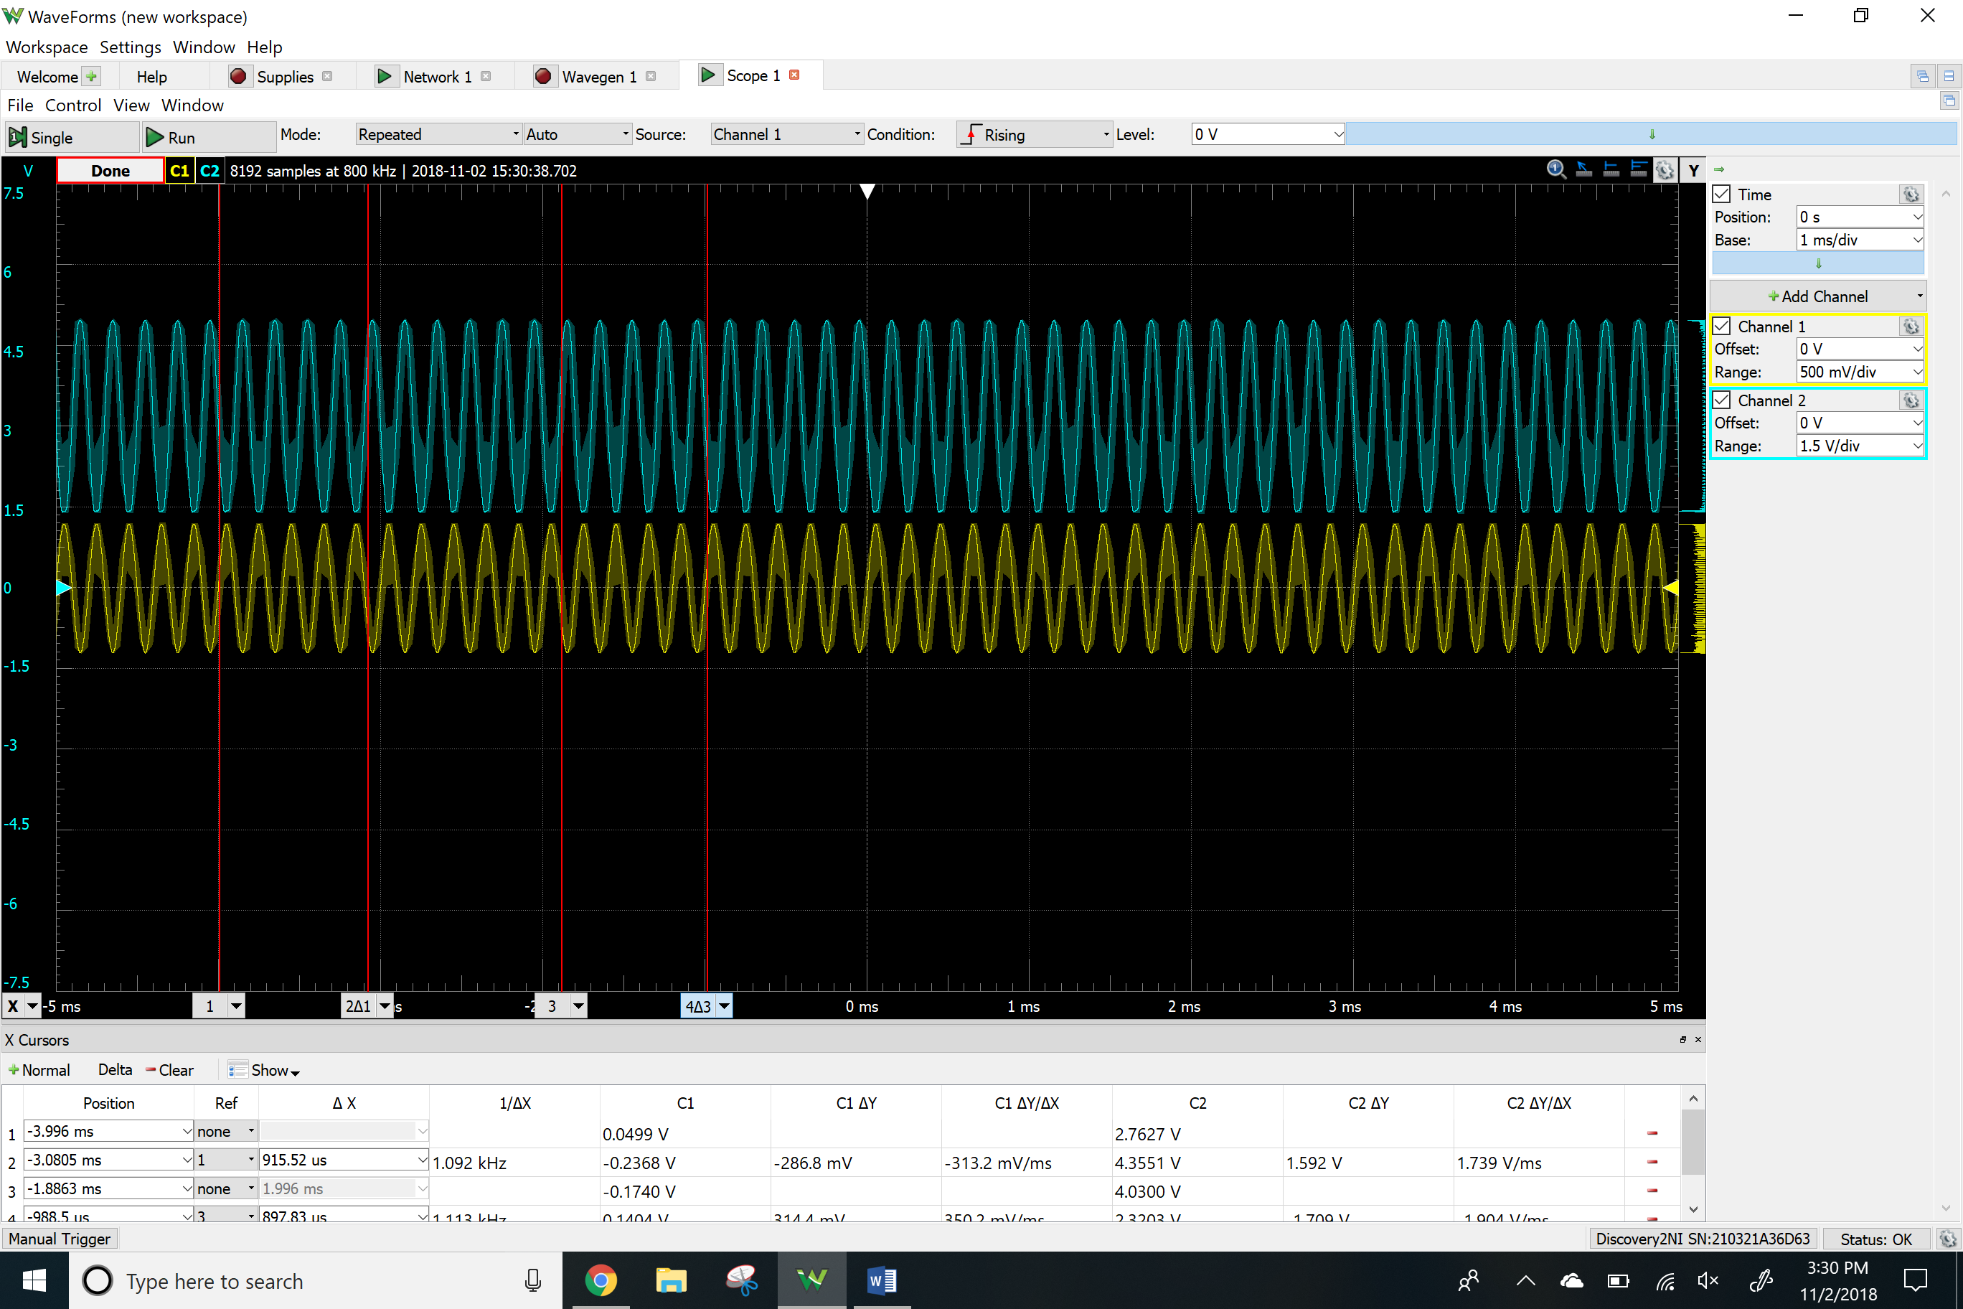

PNP common emitter

Vo and Vrb2

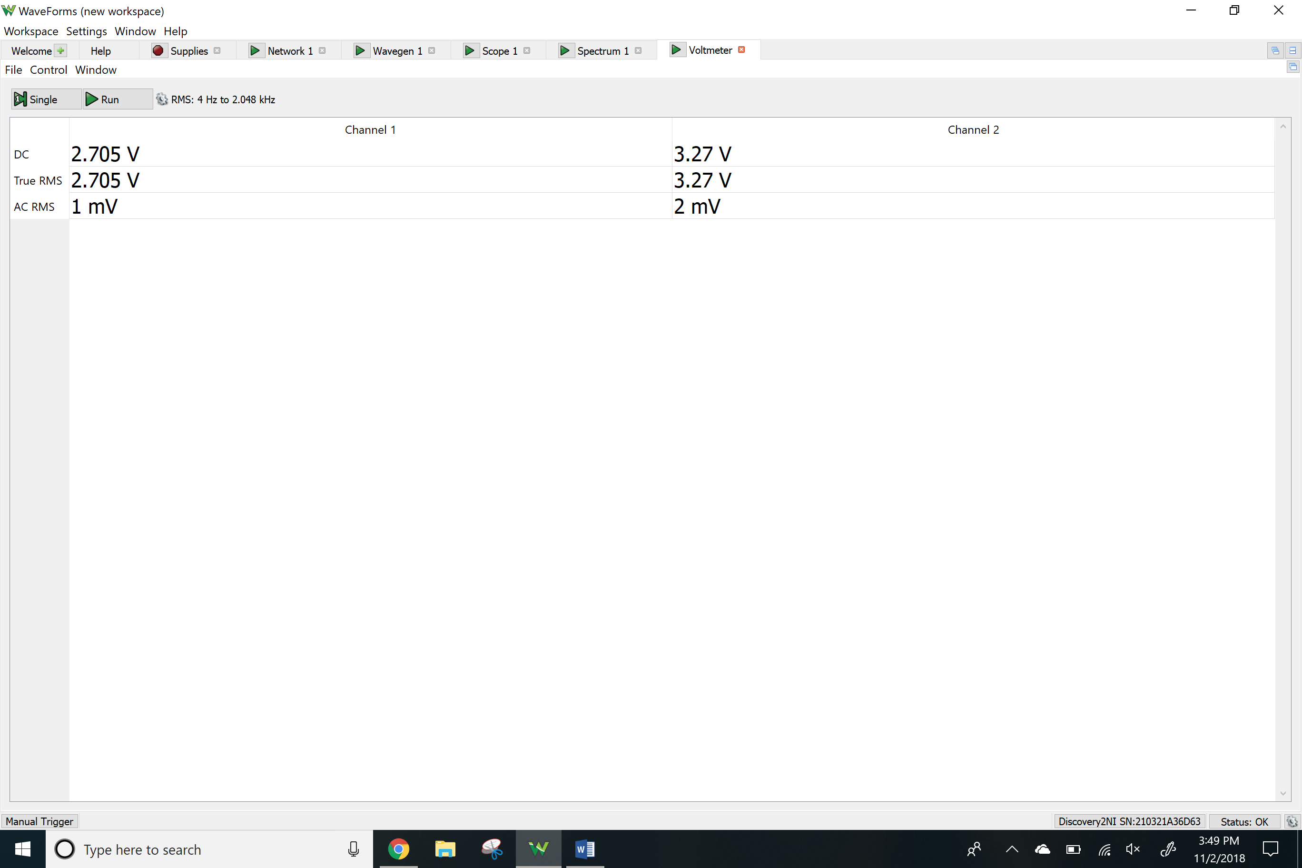Vrc and Vre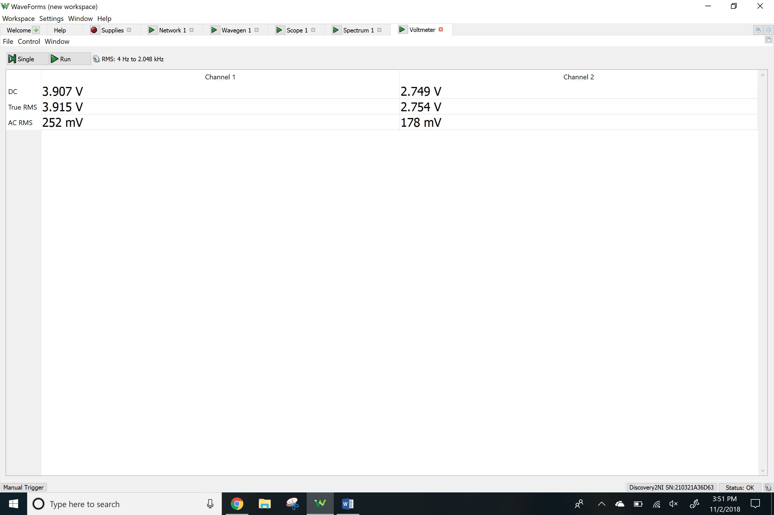

Network analyzer

Av

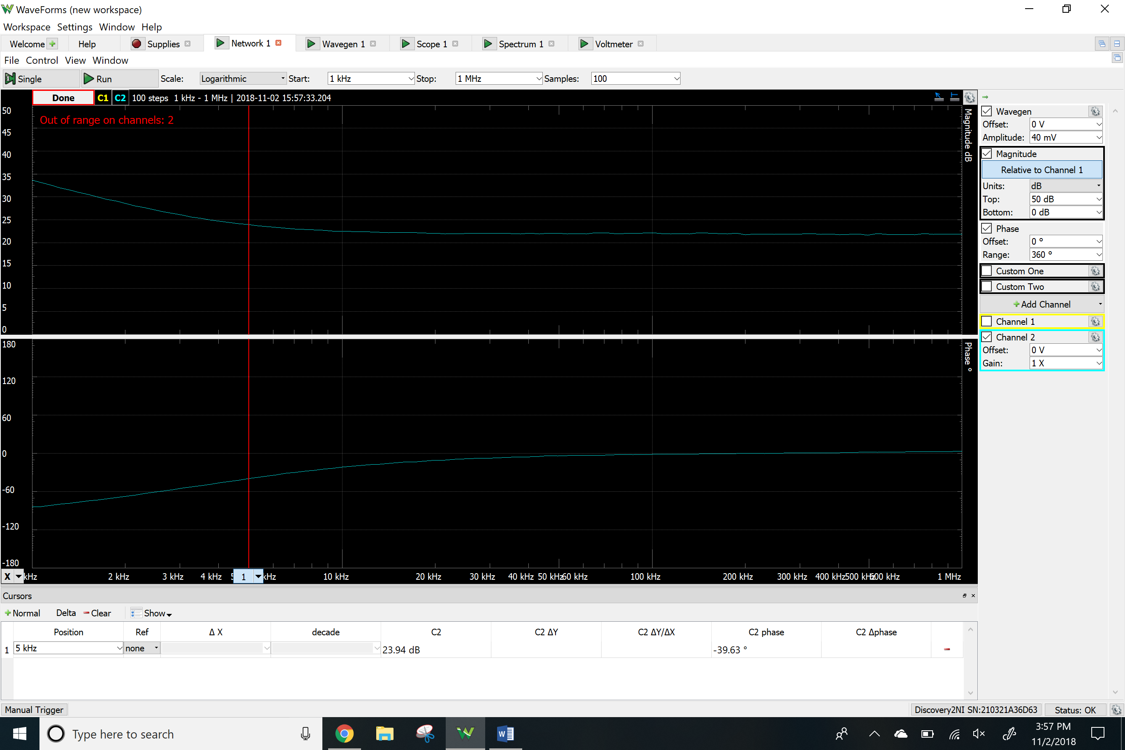Ri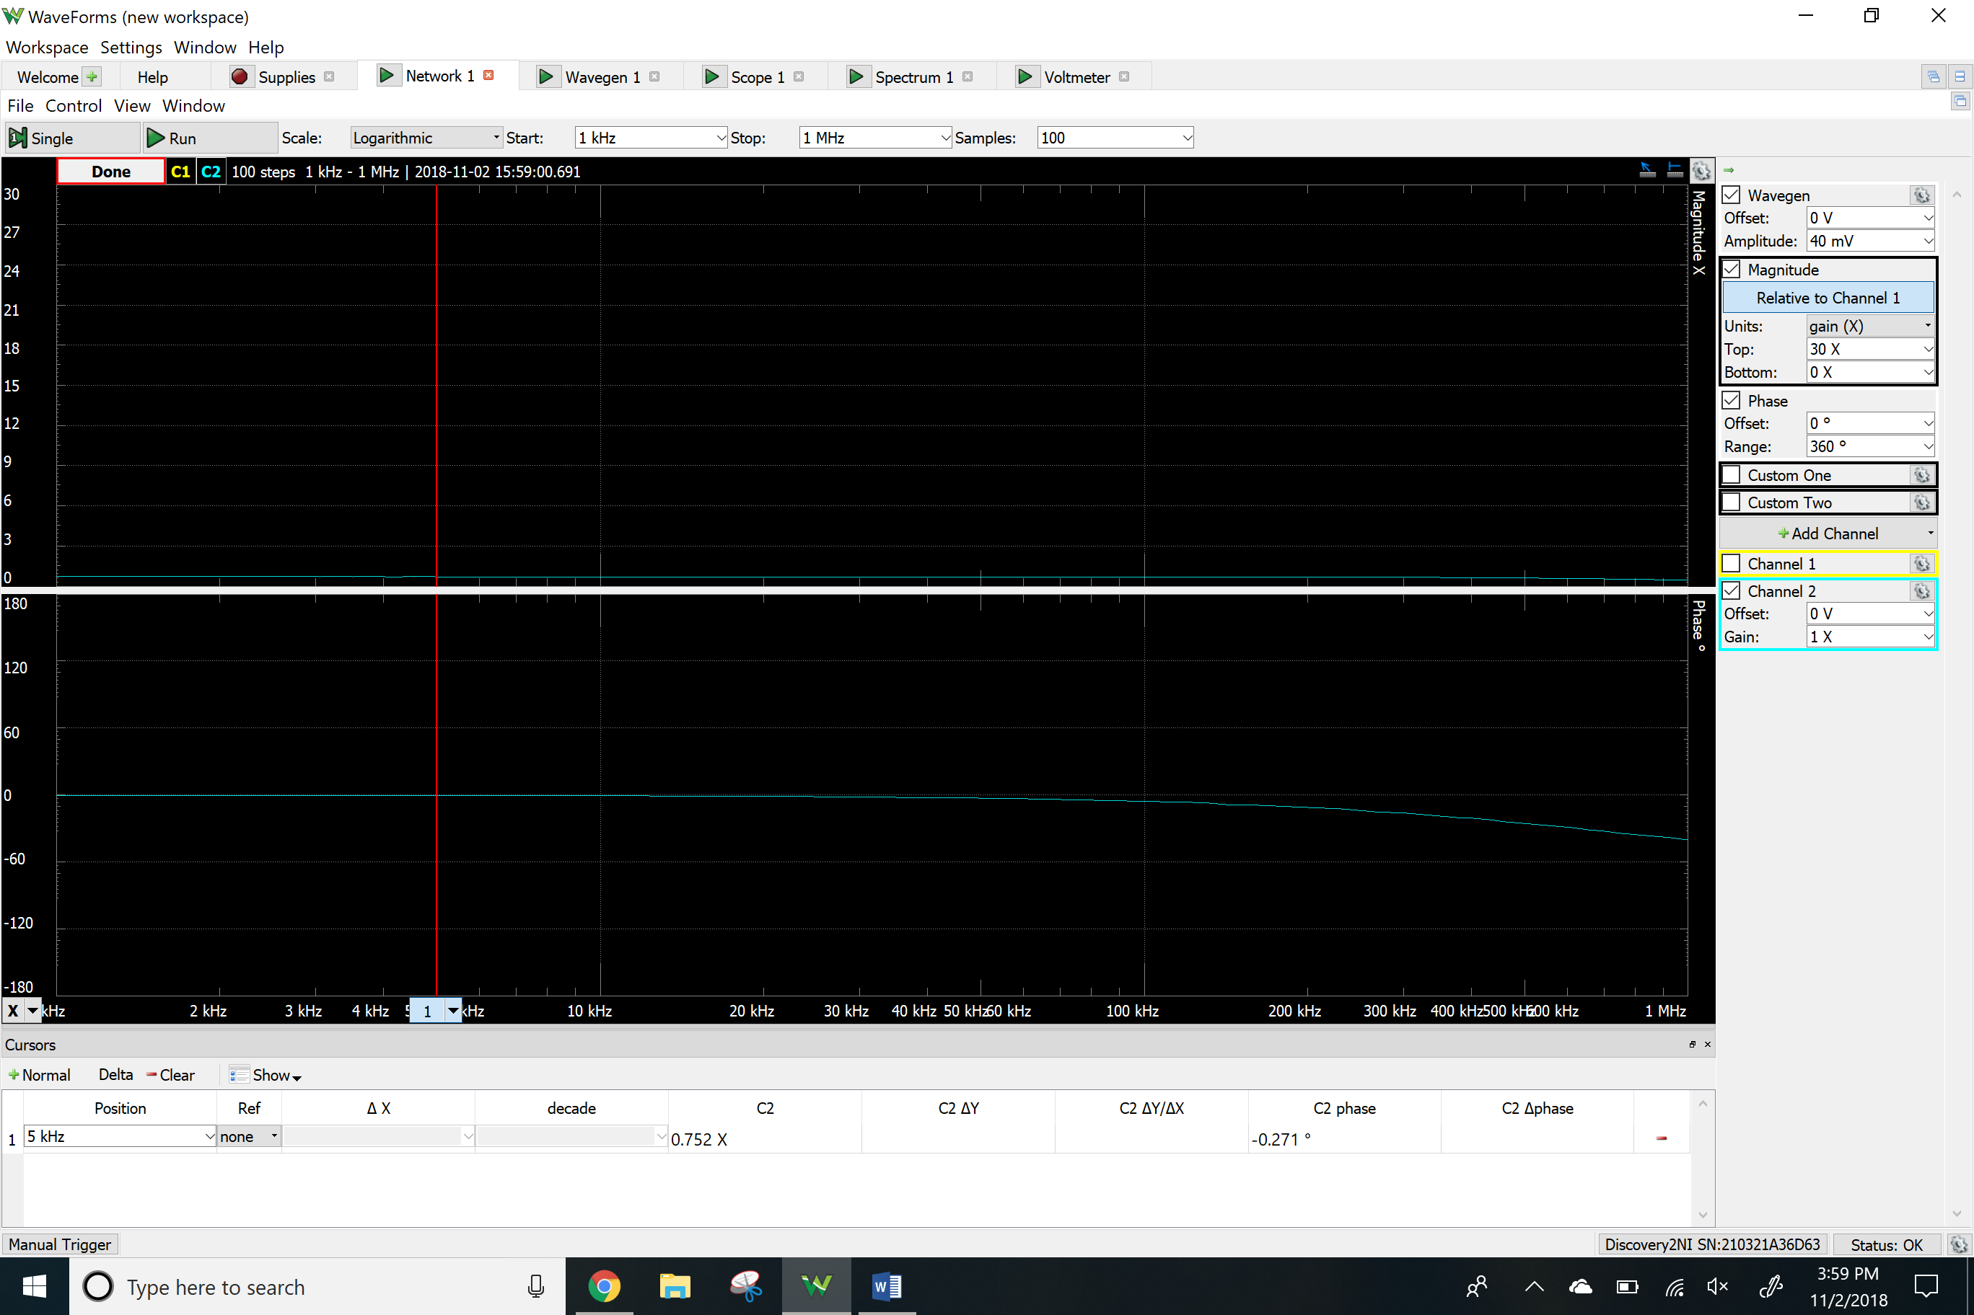

Ro

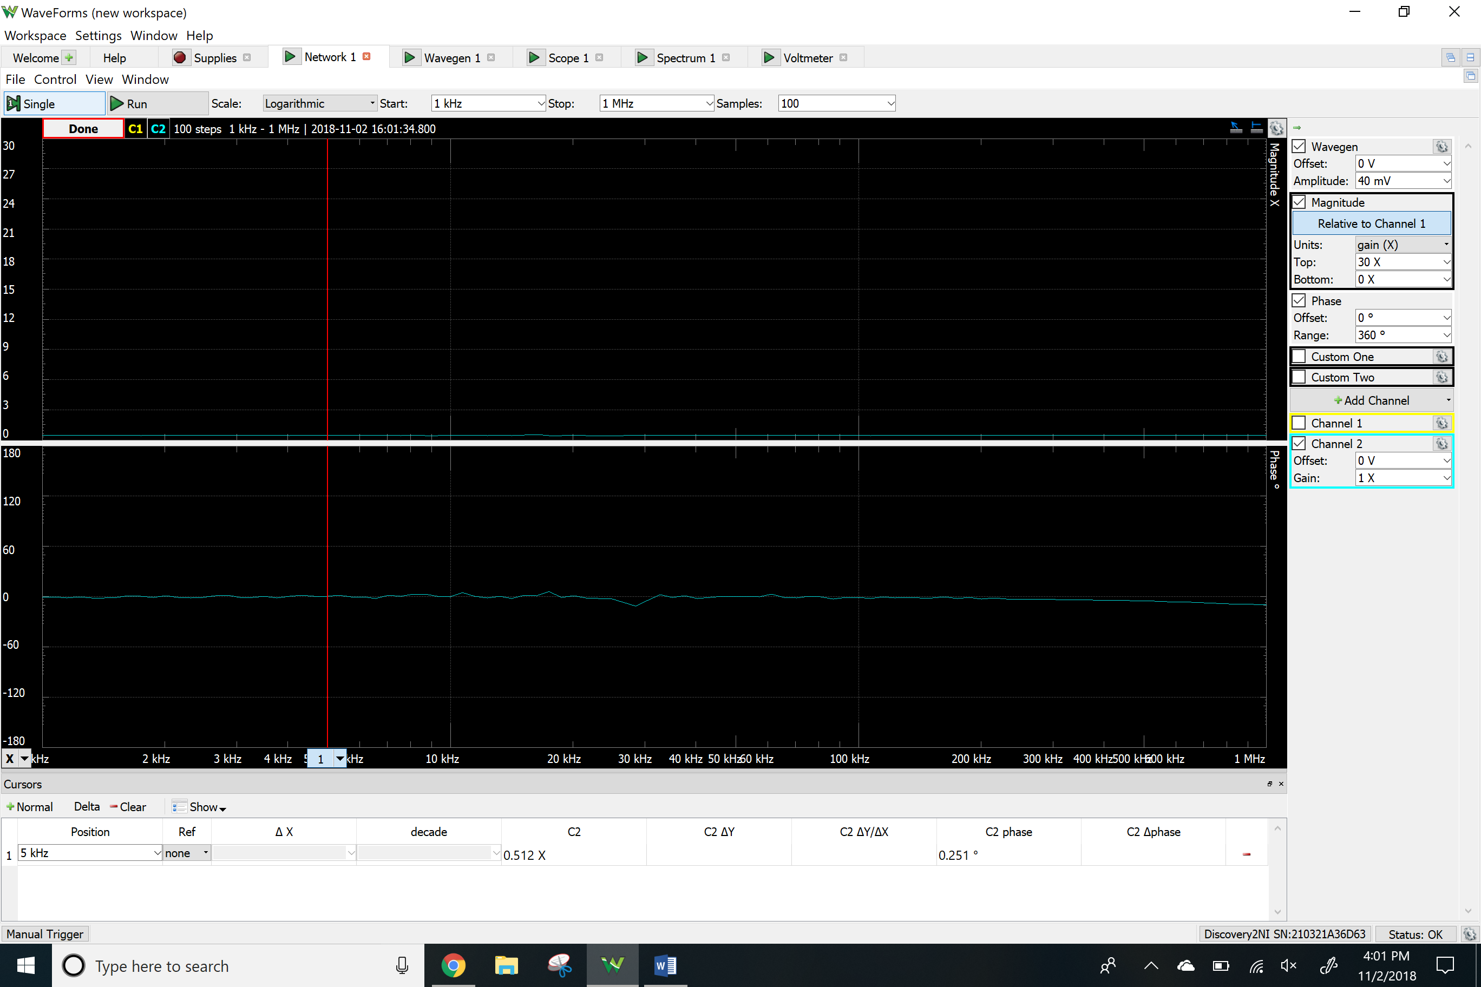Time-domain waveform

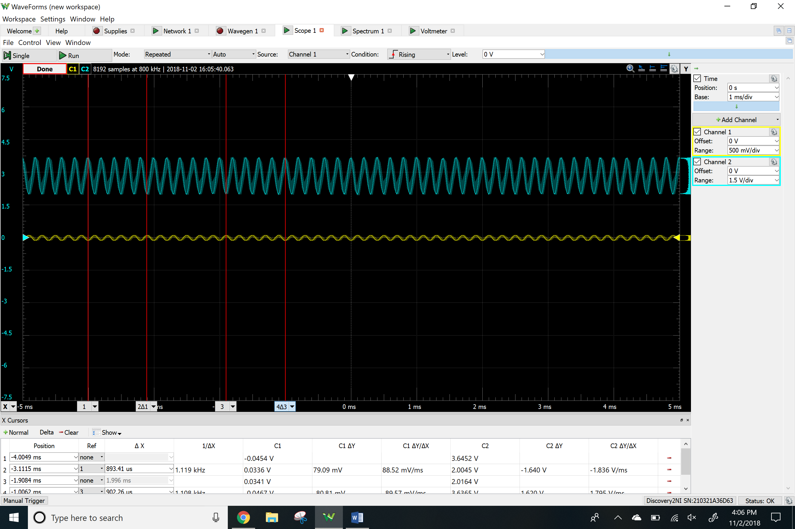

THD

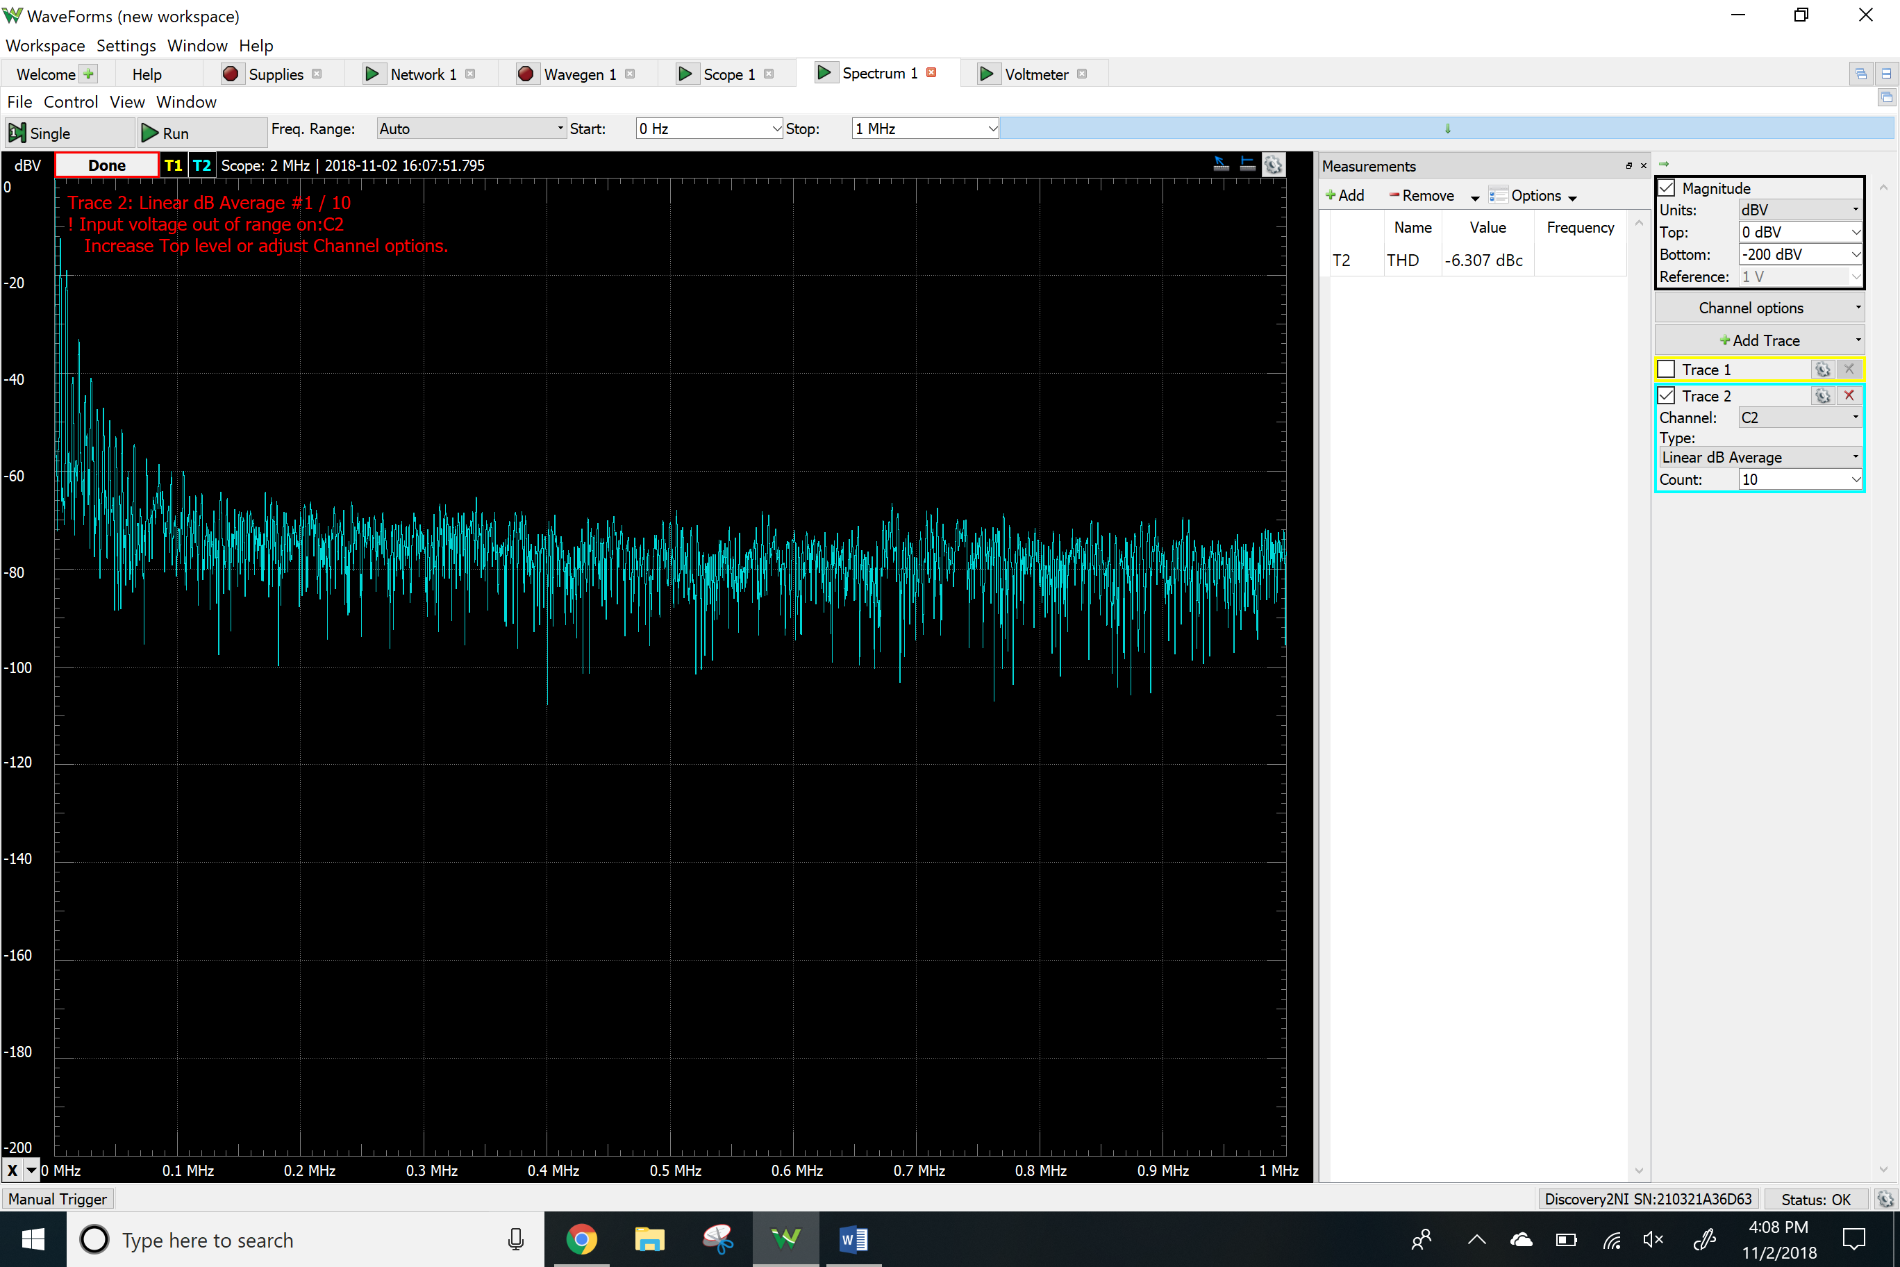

Clipping

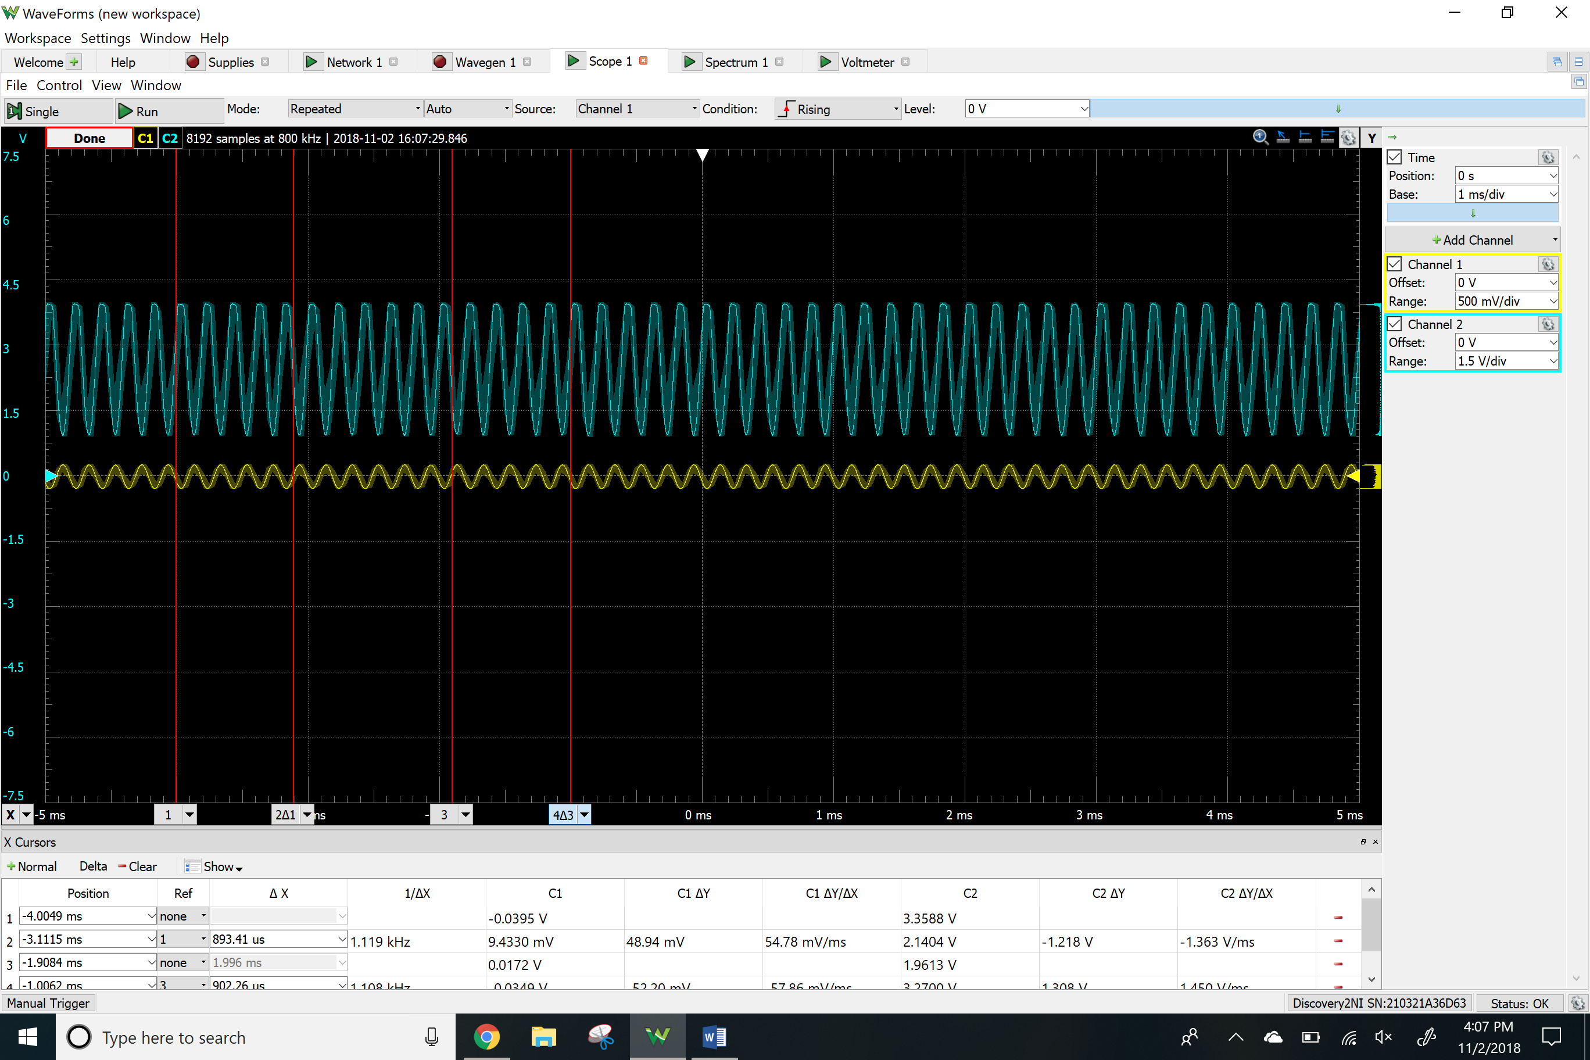

**Results**

Calculated

|  |  |
| --- | --- |
|  | Common emitter |
| Rc | 1800 Ω |
| Re | 1000 Ω |
| Rg | 32 Ω |
| Rb1 | 9900 Ω |
| Rb2 | 5100 Ω |
| C1 | 10 µF |
| C2 | 10 µF |
| Av | 25 |
| Rin | 2100 Ω |
| Rout | 1800 Ω |

Simulated

|  |  |  |
| --- | --- | --- |
|  | NPN | PNP |
| Vo | 3.19 V | 1.75 V |
| Vrb2 | 1.67 V | 1.68 V |
| Vre | 1.00 V | 979.6 mV |
| Vrc | 1.80 V | 1.75 V |
| Iq | 1.00 mA | 974.6 µA |
| Av | 24.82 | 24.19 |
| Rin | 2351 Ω | 2732 Ω |
| Rout | 1784 Ω | 1743 Ω |
| THD | 5.49 % | 5.30 % |
| Clipping | 90 mV | 90 mV |

Measured

|  |  |  |
| --- | --- | --- |
|  | NPN | PNP |
| Vo | 3.16 V | 2.70 V |
| Vrc | 1.74 V | 3.97 Vin |
| Vre | 992 mV | 2.74 V |
| Vrb2 | 1.67 V | 3.27 V |
| Iq | 1.02 mA | 1.5 mA |
| Av | 24.80 | 23.94 |
| Rin | 2521 Ω | 3032 Ω |
| Rout | 1020 Ω | 1049 Ω |
| THD | -14.95 | -6.30 |
| Clipping | 400 mV | 90 mV |

**Conclusion**

In this lab I learned that there are different basic configuration of BJT circuits and learned about their characteristic. I looked at the gain which was 25 in calculations and in the lab I got something close to 25 and the input and output impedances for each different circuit with the same component values matched both simulations and measured values. This analysis showed us that with the slight change in the input voltage will cause distort the output and can saturate it. This circuits are used to ensure proper load distribution.